
CSC 412 (3 Units)
SOFTWARE ENGINEERING
Period: Tuesday
Time: 3 P.M. to 5 P.M.
Venue: Basement

Lecturer: Joshua Nehinbe, PhD

Course outline
CSC 412: Software Engineering (3 Units)
Introduction to techniques and methodologies of software engineering; Software Design: Software architecture, Design patterns and Software life cycle models, Unified Modeling Language, OO analysis and Design, Design for re-use. Using API programming, Class browsers and related tools, Component based computing. Software tools and Environment: Requirements analysis and design modeling tool, Testing tools, integration mechanisms.

Table of Contents
Module 1 4
1. INTRODUCTION TO SOFTWARE ENGINEERING 4
IMPORTANCE OF SOFTWARE ENGINEERING 6
CHARACTERESTICS OF GOOD SOFTWARE 6
Revision questions 9
Module 2 11
SOFTWARE DEVELOPMENT LIFE CYCLE 11
2. THE SIGNIFIICANCE OF SOFTWARE LIFE CYCLE MODEL 12
Different categories of software life cycle models 13
1. CLASSICAL WATERFALL MODEL 13
2. ITERATIVE WATERFALL MODEL 20
3. PRTOTYPING MODEL 21
4. EVOLUTIONARY MODEL 23
5. SPIRAL MODEL 24
Module 3 28
3. REQUIREMENTS ANALYSIS AND SPECIFICATION 28
Functional requirements:- 29
Nonfunctional requirements:- 29
Documenting functional requirements 31
DECISION TREE 33
DECISION TABLE 35
FORMAL SYSTEM SPECIFICATION 36
Module 4 44
4. SOFTWARE DESIGN 44
Software Design Levels 44
Modularization 45
SOFTWARE DESIGN STRATEGIES 49
Structured Design 49
Function Oriented Design 50
Design Process 51
Object Oriented Design 51
Software Design Approaches 53
Top-down design 53
Bottom-up Design 53
SOFTWARE ANALYSIS & DESIGN TOOLS 54
Data Flow Diagram (DFD) 54
Data Dictionary 56
Context Diagram 60
STRUCTURED DESIGN 64
OBJECT MODELLING USING UML 67
Unified Modeling Language (UML) 68
UML Diagrams 70
USE CASE DIAGRAM 71
Utility of use case diagrams 77
Module 5 79
5. DEBUGGING, INTEGRATION AND SYSTEM TESTING 79
Brute Force Method: 79
Backtracking: 79
Cause Elimination Method: 79
Program Slicing: 80
Guidelines for Debugging Software 80
SOFTWARE TESTING 82
INTEGRATION TESTING 82
Big-Bang Integration Testing 83
Bottom-Up Integration Testing 83
Top-Down Integration Testing 84
Mixed Integration Testing 84
Phased versus Incremental Testing 85
System testing 85
Performance Testing 86
Stress Testing 86
Volume Testing 87
Compatibility Testing 87
Regression Testing 88
Recovery Testing 88
Usability Testing 89
Module 6 89
6. SOFTWARE MAINTENANCE 89
Types of software maintenance 89
Problems associated with software maintenance 90
Software Reverse Engineering 91
Reference 91

Period: Monday
Time: 3 P.M. to 5 P.M.
Venue: Basement

Module 1

1. INTRODUCTION TO SOFTWARE ENGINEERING

Software engineering is composed of two basic words, software and engineering.
Software is a collection of executable programming codes, associated libraries and documentations that link the users to the hardware of computer systems. Software that is made for a specific requirement is called software product.
Engineering deals with the usage of well-defined, scientific principles and methods to develop a product.
- Software engineering is a branch of engineering that is associated with the development of software product using well-defined scientific principles, methods and procedures. The outcome of software engineering is an efficient and reliable software product.
- Software engineering is a systematic approach to the design, development, and maintenance of software systems. It involves applying engineering principles and methodologies to create reliable, efficient and scalable software solutions. Software engineers can use various techniques, tools and best practices to manage the complexities associated with large-scale software projects to ensure that they meet the requirements of stakeholders and users.
- Software engineering is the branch of computer science that deals with the design, development, testing and maintenance of software or applications.
- Software engineers are computer professionals that apply engineering principles and knowledge of programming languages to build software solutions for end users.
IEEE defines software engineering as: the application of a systematic, disciplined, quantifiable approach to the development, operation and maintenance of software.
We can alternatively view software engineering as the systematic collection of past experience that is arranged in the form of methodologies and guidelines. A small program can be written without using software engineering principles. However, if the programmer wants to develop a large software product, then software engineering principles are absolutely necessary to achieve good quality software that is also cost effective.
It would be difficult to develop large programs without using software engineering principles. It is usually needed to develop large programs to accommodate multiple functions in industry. A problem with the development of such large commercial programs is that the complexity and difficulty levels of the programs usually increase exponentially with their sizes. Software engineering helps Software engineers to reduce the complexity in programming.
Software engineering principles use two important techniques to reduce the above complexity: abstraction and decomposition. The principle of abstraction implies that a software design problem can be simplified by omitting its irrelevant details. In other words, the main purpose of abstraction is to consider only those aspects, concepts or ideas of the problem that are relevant to the objectives of the software and ignore other aspects of the problem that are irrelevant in terms of the objectives of the software. Once the software engineers have solved the simpler problem, they can then take the other aspects of the software into consideration by solving the next lower-level abstraction of the problem, and so on. Abstraction of the software is a powerful way of reducing the complexity with the development problems that associate with software designs. The other approach is to tackle the complexity of the software problem by decomposition. In this technique, the software engineers breakdown the complex software problems into several smaller (associated) problems and then solve them one-by-one. However, in this technique any random decomposition of the software problems into smaller parts will not facilitate robust software solution. Software development problems must be decomposed into sub-component such that each component (of the decomposed problems) can be solved independently and then the solutions of the different components can be combined to get the comprehensive software solution. A good decomposition of software problems should minimize the interactions among various components. If the different subcomponents are interrelated, then the different components cannot be solved separately and the software engineers will not be able to realize the desired reduction in complexity of the software problems.

IMPORTANCE OF SOFTWARE ENGINEERING
Software engineering arises because of the higher rate of change in users’ requirements and the dynamic nature of the environment or platform on which the software is design to work or operate. The importance of software engineering are quite many and they are often discussed in various perspectives.
- Large software - As the size of the software becomes large engineering has to step in to add the scientific process to the process of design the standard software.
- Scalability- Scalability is the ability of a computing task to be used or produced in a range of capabilities. Scalability in software development refers to designing software solutions that continue to function efficiently with a growing number of users. This means that regardless of how the business continues to grow, the software must capable of handling the increase in the numbers of end-users, customers, transactions, requests, etc. Usually, it would be easier to re-create new software rather than to scale up existing software especially if the software process were not previously based on standard scientific and engineering concepts.
- Cost- Software engineering enables experts to design software that is cost effective both in terms of hardware cost, the cost of software (license), installation and maintenance.
- Dynamic Nature- Software is always growing and adapting in nature. The enabling platform and users’ requirements are dynamic and most of them depend upon the environment in which the user works. New enhancement will be need to the existing software if its nature is changing. Software engineering enables software developers to design software products that can dynamically meet the trend in software industry.
- Quality Management- Software engineering facilitates better process of software development so that software engineers can achieve better and quality software products.

Without adopting suitable software engineering methodologies, principles and tools, it will be very difficult for software products to function or accomplish the objectives of the software or maintain a desired level of excellence. In essence, the main purpose of software engineering is to develop reliable, efficient, and scalable software solutions to effectively meet the needs of end-users and business communities. It assists developers to determine software quality and adhere to best practice during the planning, creation, implementation and maintenance or quality improvement.

CHARACTERESTICS OF GOOD SOFTWARE
A software product can be judged by its quality (value-adding), functionalities (what it offers) and user-friendly (how well it can be used by end-users). Good software must satisfy the following three conditions:
- Operational
- Transitional
- Maintenance

The Operational quality of software products deals with functioning, working and its readiness to be used by end-users. Thus, a well-engineered software is expected to work well in its environment. Such characteristics can be measured on the basis of:
- Budget (revenue and expenses (finances) that are made from the software products for a specified period of time (or use) must be reasonable)
- Usability (End-users must be able to easily use the software and its interfaces)
- Efficiency (works without wasting time or energy of end-user; useful, helpful and worth its cost)
- Correctness (high accuracy, free from error and conformity to the accepted best standards)
- Functionality (well-designed attributes, suited to well for its purpose)
- Dependability (reliable, trustworthy, do what end-users and stakeholders expect, offers value for its cost and comfortable to use)
- Security (harmless (i.e. free from danger or threat) and safety measures (i.e. has guarantee of the fulfilment of adequate protection to end-users and other computing resources)
- Safety (defensive mechanism require to achieve resistance to intrusions; protected from intrusion, danger, risk, etc)
- Navigation (user-friendly, accessible, understandable to end-users while moving around (or accessing) the functionalities of the software product. A good software must make end-users feel relaxed and happy to use and navigate through its functionalities.

The transitional, quality of a good software focuses the characteristics of a software product during the process or period of its transition, migration, installation, upgrade, etc. A good software must be able to be conveniently migrated or installed from one platform (or initial platform, i.e. working environment) to another. The transitional quality of software is measured on the basis of:
• Portability (easily transferred, installed, or set up)
• Interoperability (interact, to exchange and make use of information or function, wok together and connect with other ancillary software, utilities, etc)
• Reusability (capable of being used again or reuse repeatedly)
• Adaptability (adaptable, flexible, capable to adjust to new conditions, modified to meet a new requirements or purpose.)

Maintenance
Maintenance deals with how well the software can be maintained, upgraded, retained or continued to be used by end-users in the dynamic (or ever-changing) environment. Software that has maintenance quality must possess the following characteristics:
- Modularity: The quality of gradually repairing the software from a separate functional unit (i.e. module) to another module such that whole software is repaired or upgraded from its component parts.
- Maintainability: The capability of the software to be restored to a working condition whenever its maintenance is carried out especially by skilled personnel.
- Flexibility: The ability of the software to respond to uncertainty in the manner that allows it to accurately function on the average.
- Scalability: The capacity of the software to handle additional workload efficiently and effectively even if the tasks is increased.

Essentially, Software engineering is a branch of computer science that uses well-defined engineering concepts required to produce efficient, durable, scalable, financially planned and prompt software products
Functions of software engineers
- Design and maintain software systems or applications (apps)
- Evaluate and testing new software programs
- Optimizing software for improved speed and scalability
- Writing and testing source codes
- Ensuring that the software is compatible with enabling operating and hardware systems
- Creating and ensuring that the software enforcing IT standards within an infrastructure
- Maintaining documentation of IT systems
- Releasing software updates
- Collaborating with development teams, senior systems architects and data science professionals to develop good software products
- Consulting with clients, network engineers, security specialists and other stakeholders on the design, development, testing and maintenance of software or digital applications.
- Recommending software upgrades for the existing programs and systems
- Presenting new features of software to the stakeholders and internal customers
According to the IEEE, the software engineering body of knowledge falls into ten distinct areas and each of them is called a knowledge area. These ten knowledge areas are as follows:

  - Software requirements
  - Software design
  - Software construction
  - Software testing
  - Software maintenance
  - Software configuration management
  - Software engineering management
  - Software engineering process
  - Software engineering tools and methods
  - Software quality

Revision questions
1. What is software engineering?
2. Discuss the importance of software engineering and establish how software engineering satisfies the complex and constantly evolving software development field.
3. Briefly explain the following characteristics of good software: Efficiency, Maintainability, Reliability, Usability, Portability, Software testability, Correctness, Reusability, Security, Flexibility, Integrity, Interoperability, Adaptability, Safety, Scalability, Availability, Design independence, Understandability, Functionality, Dependability, Compatibility, Effectiveness, Modifiability and Performance

Module 2

SOFTWARE DEVELOPMENT LIFE CYCLE
A Software Development Life Cycle (SDLC) model (i.e. software process model) is a systematic descriptive and diagrammatic representation of the software life cycle. SDLC is a defined methodology for creating high-quality software and the overall development process of the software. The SDLC methodology focuses on the following six key activities or phases required to develop software:
- Requirement analysis
- Planning
- Software design (such as architectural design)
- Software development
- Testing
- Deployment

The SDLC framework also captures the order in which the above six activities are to be undertaken. In other words, a life cycle model maps the different activities performed on a software product from its inception to retirement. Different life cycle models may map the basic development activities to phases in different ways. Thus, no matter which life cycle model is followed, the basic activities are included in all life cycle models though the activities may be carried out in different orders in different life cycle models. During any life cycle phase, more than one activity may also be carried out. In essence, software life cycle is used to describe a process for planning, creating, testing, deploying and maintenance software.

2. THE SIGNIFIICANCE OF SOFTWARE LIFE CYCLE MODEL
The development team must identify a suitable life cycle model for the particular project and then adhere to it so that they can produce software with the highest quality and at lowest cost within a shortest time frame. SDLC provides a well-structured flow of phases that can help an organization to quickly produce high-quality software that is well-planned, developed, tested and deployed in accordance with best global practice.
Without using a particular life cycle model the development of a software product would not be in a systematic and disciplined manner. When a software product is being developed by a team there must be a clear understanding among team members about when and what to do. Otherwise, it would lead to chaos and project failure. There are numerous ways to illustrate potential issues and challenges that can confront software development team during software designs and development. Suppose a software development task is divided into several parts and the parts are assigned to different team members. The team members may develop the parts assigned to them in whatever way they like. It is possible that one member might start writing the code for his/her part, another might decide to prepare the test documents first, and some other software engineers might begin with the design phase of the parts assigned to him. Lack of uniform methodology is a perfect step towards the failure of the software project.
A software life cycle model therefore defines the entry and exit criteria for every phase of software development. A phase can start only if its phase-entry criteria have been satisfied. So, without software life cycle model, the entry and exit criteria for a phase cannot be recognized. Without software life cycle models, it becomes difficult for software project managers to accurately monitor the progress and development of the software project.

Different categories of software life cycle models
Many life cycle models have been proposed over the years. Each of them has some advantages as well as some disadvantages. A few important and commonly used life cycle models include:
• Classical Waterfall Model
• Iterative Waterfall Model
• Prototyping Model
• Evolutionary Model
• Spiral Model
• Agile methodology
• Lean development
• Rapid Application Development (RAD)
• Dynamic System Model
• Feature Driven Development (FDD)
• Scrum
There are hundreds of different life cycle models like waterfall, code-and-fix, spiral, rapid prototyping, evolutionary, unified, agile method, etc

1. CLASSICAL WATERFALL MODEL
The classical waterfall model is intuitively the most obvious way to develop software. Though the classical waterfall model is elegant and intuitively obvious, it is not a practical model in the sense that it cannot be used in actual software development projects.
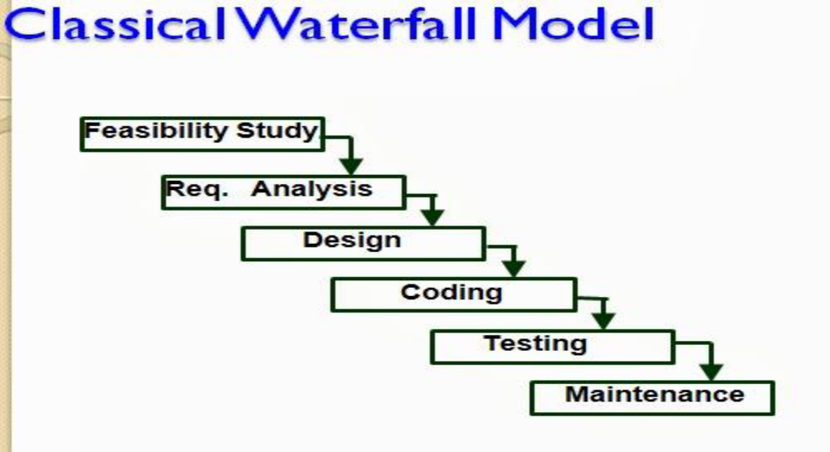

Fig 2.1: Classical Waterfall Model
Thus, this model can be considered to be a theoretical way of developing software. But all other life cycle models are essentially derived from the classical waterfall model. So, in order to be able to appreciate other life cycle models it is necessary to learn the classical waterfall model. Classical waterfall model divides the life cycle into the following phases as shown in Fig.2.1.
Feasibility study - The main aim of feasibility study is to determine whether it would be financially and technically feasible to develop the product.
• At first project managers or team leaders try to have a rough understanding of what is required to be done by visiting the client side. They study different input data to the system and output data to be produced by the system. They study what kind of processing that is needed to be done on these data and they look at the various constraints on the behavior of the system.

• After they have an overall understanding of the problem they investigate the different solutions that are possible. Then they examine each of the solutions in terms of what kind of resources required, what would be the cost of development and what would be the development time for each solution.

• Based on this analysis they select the best solution and determine whether the solution is feasible (possible0 financially and technically. They check whether the customer’s budget would meet the cost of the product and whether they have sufficient technical expertise in the area of its development.

Requirements analysis and specification: - The aim of the requirements analysis and specification phase is to understand the exact requirements of the customer and to document them properly. This phase consists of two distinct activities, namely
• Requirements gathering and analysis
• Requirements specification

The goal of the requirement’s gathering activity is to collect all relevant information from the customer regarding the product to be developed. This is done to clearly understand the customer requirements so that incompleteness and inconsistencies are removed.
The requirements analysis activity is begun by collecting all relevant data regarding the product to be developed from the users of the product and from the customer through interviews and discussions. For example, to perform the requirements analysis of a business accounting software required by an organization, the analyst might interview all the accountants of the organization to ascertain their requirements. The data collected from such a group of users usually contain several contradictions and ambiguities, since each user typically has only a partial and incomplete view of the system. Therefore it is necessary to identify all ambiguities and contradictions in the requirements and resolve them through further discussions with the customer. After all ambiguities, inconsistencies, and incompleteness have been resolved and all the requirements properly understood, the requirements specification activity can start. During this activity, the user requirements are systematically organized into a Software Requirements Specification (SRS) document. The customer requirements identified during the requirements gathering and analysis activity are organized into a SRS document. The important components of this document are functional requirements, the nonfunctional requirements, and the goals of implementation.

Design: - The goal of the design phase is to transform the requirements specified in the SRS document into a structure that is suitable for implementation in some programming language. In technical terms, during the design phase the software architecture is derived from the SRS document. Two distinctly different approaches are available: the traditional design approach and the object-oriented design approach.
• Traditional design approach -Traditional design consists of two different activities; first a structured analysis of the requirements specification is carried out where the detailed structure of the problem is examined. This is followed by a structured design activity. During structured design, the results of structured analysis are transformed into the software design.
• Object-oriented design approach -In this technique, various objects that occur in the problem domain and the solution domain are first identified, and the different relationships that exist among these objects are identified. The object structure is further refined to obtain the detailed design. In other words, Object oriented design works around the entities and their characteristics instead of functions involved in the software system. This design strategy focuses on entities and its characteristics. The whole concept of software solution revolves around the engaged entities. Let us see the important concepts of Object Oriented Design:
Objects - All entities involved in the solution design are known as objects. For example, person, banks, company and customers are treated as objects. Every entity has some attributes associated to it and has some methods to perform on the attributes.
Classes - A class is a generalized description of an object. An object is an instance of a class. Class defines all the attributes, which an object can have and methods, which defines the functionality of the object. In the solution design, attributes are stored as variables and functionalities are defined by means of methods or procedures.
Encapsulation - In OOD, the attributes (data variables) and methods (operation on the data) are bundled together and it is called encapsulation. Encapsulation not only bundles important information of an object together, but also restricts access of the data and methods from the outside world. This is called information hiding.
Inheritance - OOD allows similar classes to stack up in hierarchical manner where the lower or sub-classes can import, implement and re-use allowed variables and methods from their immediate super classes. This property of OOD is known as inheritance. This makes it easier to define specific class and to create generalized classes from specific ones.
Polymorphism - OOD languages provide a mechanism where methods performing similar tasks but vary in arguments, can be assigned same name. This is called polymorphism, which allows a single interface performing tasks for different types. Depending upon how the function is invoked, respective portion of the code gets executed.

Coding and unit testing:-The purpose of the coding phase (sometimes called the implementation phase) of software development is to translate the software design into source code. Each component of the design is implemented as a program module. The end-product of this phase is a set of program modules that have been individually tested. During this phase, each module is unit tested to determine the correct working of all the individual modules. It involves testing each module in isolation as this is the most efficient way to debug the errors identified at this stage.
Integration and system testing: -Integration of different modules is undertaken once they have been coded and unit tested. During the integration and system testing phase, the modules are integrated in a planned manner. The different modules making up a software product are almost never integrated in one shot. Integration is normally carried out incrementally over a number of steps. During each integration step, the partially integrated system is tested and a set of previously planned modules are added to it. Finally, when all the modules have been successfully integrated and tested, system testing is carried out. The goal of system testing is to ensure that the developed system conforms to its requirements laid out in the SRS document. System testing usually consists of three different kinds of testing activities:
• α – testing: It is the system testing performed by the development team.
• β –testing: It is the system testing performed by a friendly set of customers.
• Acceptance testing: It is the system testing performed by the customer himself after the product delivery to determine whether to accept or reject the delivered product.
System testing is normally carried out in a planned manner according to the system test plan document. The system test plan identifies all testing-related activities that must be performed, specifies the schedule of testing, and allocates resources. It also lists all the test cases and the expected outputs for each test case.
Maintenance: -Maintenance of a typical software product requires much more than the effort necessary to develop the product itself. Many studies carried out in the past confirm this and indicate that the relative effort of development of a typical software product to its maintenance effort is roughly in the 40:60 ratios. Maintenance involves performing any one or more of the following three kinds of activities:
• Correcting errors that were not discovered during the product development phase. This is called corrective maintenance.
• Improving the implementation of the system, and enhancing the functionalities of the system according to the customer’s requirements. This is called perfective maintenance.
• Porting the software to work in a new environment. For example, porting may be required to get the software to work on a new computer platform or with a new operating system. This is called adaptive maintenance.
Shortcomings of the classical waterfall model
The classical waterfall model is an idealistic one since it assumes that no development error is ever committed by the engineers during any of the life cycle phases. However, in practical development environments, the engineers do commit a large number of errors in almost every phase of the life cycle. The source of the defects can be many: oversight, wrong assumptions, use of inappropriate technology, communication gap among the project engineers, etc. These defects usually get detected much later in the life cycle. For example, a design defect might go unnoticed till we reach the coding or testing phase. Once a defect is detected, the engineers need to go back to the phase where the defect had occurred and redo some of the work done during that phase and the subsequent phases to correct the defect and its effect on the later phases. Therefore, in any practical software development work, it is not possible to strictly follow the classical waterfall model.

2. ITERATIVE WATERFALL MODEL

To overcome the major shortcomings of the classical waterfall model, we come up with the iterative waterfall model.
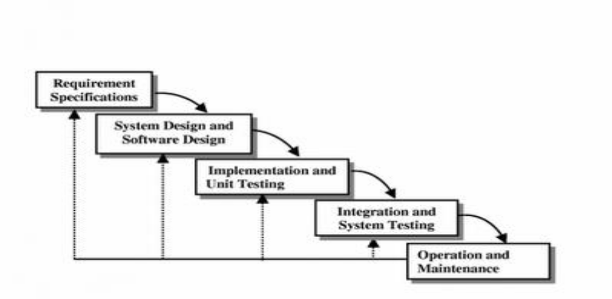

Fig 2.2 : Iterative Waterfall Model
Here, we provide feedback paths for error correction as and when detected later in a phase. Though errors are inevitable, but it is desirable to detect them in the same phase in which they occur. If so, this can reduce the effort to correct the bug.
The advantage of this model is that there is a working model of the system at a very early stage of development which makes it easier to find functional or design flaws. Finding issues at an early stage of development enables to take corrective measures in a limited budget.
The disadvantage with this SDLC model is that it is applicable only to large and bulky software development projects. This is because it is hard to break a small software system into further small serviceable increments/modules.

3. PRTOTYPING MODEL
A prototype is a toy implementation of the system. A prototype usually exhibits limited functional capabilities, low reliability, and inefficient performance compared to the actual software. A prototype is usually built using several shortcuts. The shortcuts might involve using inefficient, inaccurate, or dummy functions. The shortcut implementation of a function, for example, may produce the desired results by using a table look-up instead of performing the actual computations. A prototype usually turns out to be a very crude version of the actual system.
Need for a prototype in software development
There are several uses of a prototype. An important purpose is to illustrate the input data formats, messages, reports, and the interactive dialogues to the customer. This is a valuable mechanism for gaining better understanding of the customer’s needs:
• how the screens might look like
• how the user interface would behave
• how the system would produce outputs

Another reason for developing a prototype is that it is impossible to get the perfect product in the first attempt. Many researchers and engineers advocate that if you want to develop a good product you must plan to throw away the first version. The experience gained in developing the prototype can be used to develop the final product.
A prototyping model can be used when technical solutions are unclear to the development team. A developed prototype can help engineers to critically examine the technical issues associated with the product development. Often, major design decisions depend on issues like the response time of a hardware controller, or the efficiency of a sorting algorithm, etc. In such circumstances, a prototype may be the best or the only way to resolve the technical issues.
A prototype of the actual product is preferred in situations such as:
• User requirements are not complete
• Technical issues are not clear

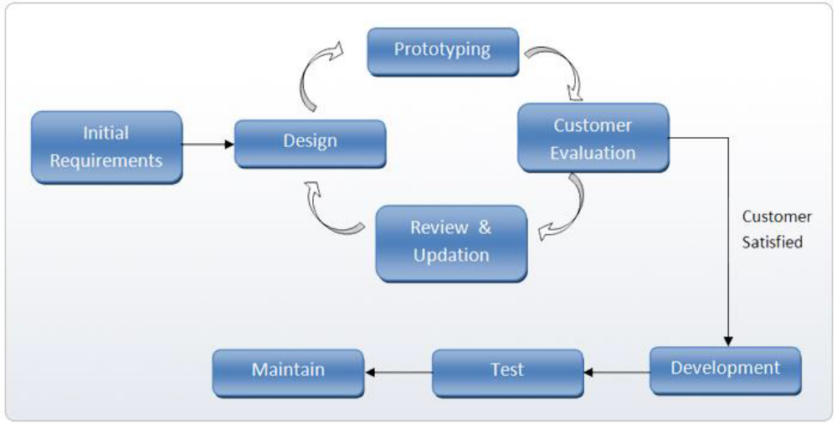
Fig 2.3: Prototype Model

4. EVOLUTIONARY MODEL
It is also called successive versions model or incremental model. At first, a simple working model is built. Subsequently it undergoes functional improvements and we keep on adding new functions till the desired system is built.
Applications:
• Large projects where you can easily find modules for incremental implementation. Often used when the customer wants to start using the core features rather than waiting for the full software.
• Also used in object-oriented software development because the system can be easily portioned into units in terms of objects.

Advantages:
• User gets a chance to experiment partially developed system
• Reduce the error because the core modules get tested thoroughly.
Disadvantages:
• It is difficult to divide the problem into several versions that would be acceptable to the customer which can be incrementally implemented and delivered.
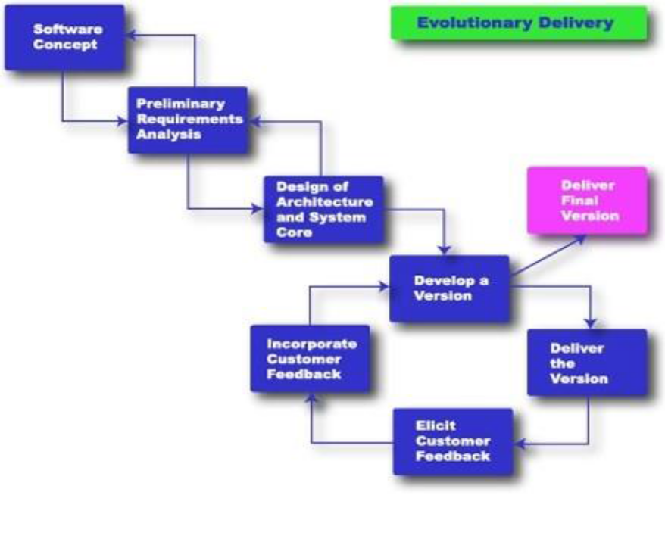

Fig 2.4: Evolutionary Model

5. SPIRAL MODEL
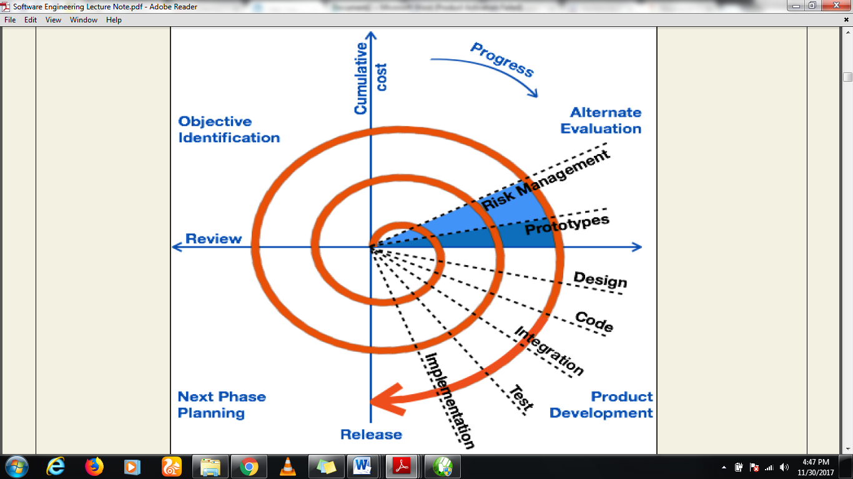
The Spiral model of software development is shown in fig. 4.1. The diagrammatic representation of this model appears like a spiral with many loops. The exact number of loops in the spiral is not fixed. Each loop of the spiral represents a phase of the software process. For example, the innermost loop might be concerned with feasibility study, the next loop with requirements specification, the next one with design, and so on. Each phase in this model is split into four sectors (or quadrants) as shown in fig. 4.1. The following activities are carried out during each phase of a spiral model.

Fig 2.5: Spiral Model

First quadrant (Objective Setting)
• During the first quadrant, it is needed to identify the objectives of the phase.
• Examine the risks associated with these objectives.
Second Quadrant (Risk Assessment and Reduction)
• A detailed analysis is carried out for each identified project risk.
• Steps are taken to reduce the risks. For example, if there is a risk that the requirements are inappropriate, a prototype system may be developed.
Third Quadrant (Development and Validation)
• Develop and validate the next level of the product after resolving the identified risks.
Fourth Quadrant (Review and Planning)
• Review the results achieved so far with the customer and plan the next iteration around the spiral.
• Progressively more complete version of the software gets built with each iteration around the spiral.
Circumstances to use spiral model
The spiral model is called a meta model since it encompasses all other life cycle models. Risk handling is inherently built into this model. The spiral model is suitable for development of technically challenging software products that are prone to several kinds of risks. However, this model is much more complex than the other models – this is probably a factor deterring its use in ordinary projects.
Comparison of different life-cycle models
The classical waterfall model can be considered as the basic model and all other life cycle models as embellishments of this model. However, the classical waterfall model cannot be used in practical development projects, since this model supports no mechanism to handle the errors committed during any of the phases.
This problem is overcome in the iterative waterfall model. The iterative waterfall model is probably the most widely used software development model evolved so far. This model is simple to understand and use. However this model is suitable only for well-understood problems; it is not suitable for very large projects and for projects that are subject to many risks.
The prototyping model is suitable for projects for which either the user requirements or the underlying technical aspects are not well understood. This model is especially popular for development of the user-interface part of the projects.

The evolutionary approach is suitable for large problems which can be decomposed into a set of modules for incremental development and delivery. This model is also widely used for object-oriented development projects. Of course, this model can only be used if the incremental delivery of the system is acceptable to the customer.
The spiral model is called a meta model since it encompasses all other life cycle models. Risk handling is inherently built into this model. The spiral model is suitable for development of technically challenging software products that are prone to several kinds of risks. However, this model is much more complex than the other models – this is probably a factor deterring its use in ordinary projects.
The different software life cycle models can be compared from the viewpoint of the customer. Initially, customer confidence in the development team is usually high irrespective of the development model followed. During the lengthy development process, customer confidence normally drops off, as no working product is immediately visible. Developers answer customer queries using technical slang, and delays are announced. This gives rise to customer resentment. On the other hand, an evolutionary approach lets the customer experiment with a working product much earlier than the monolithic approaches. Another important advantage of the incremental model is that it reduces the customer’s trauma of getting used to an entirely new system. The gradual introduction of the product via incremental phases provides time to the customer to adjust to the new product. Also, from the customer’s financial viewpoint, incremental development does not require a large upfront capital outlay. The customer can order the incremental versions as and when he can afford them.

6. AGILE DEVELOPMENT METHODOLOGY

Overview
Agile methodology is arguably one of the most popular software development methodologies in recent days. It takes a different approach from the conventional, linear method. Agile focuses on how to satisfy the users instead of emphasizing documentation and rigid procedures.
With Agile, tasks are broken into short sprints that take about 1 to 4 weeks to complete. It’s an iterative model that involves multiple tests as the development progresses. Developers continuously seek feedback from customers and make changes to the software.
Communication is the priority in Agile, particularly between developers, customers, and users.

Pros
- Software has minimal defects due to the iterative effort in testing and fine-tuning.
- Clarity between team members during development, thanks to the frequent and transparent development.
- Changes in project requirements are easily addressed and work on with little impact on the timeline.
- An overall improvement on the deliverable’s quality.

Cons
- The team can sometimes lose focus due to overwhelming change requests.
- Documentation takes a back seat in Agile, which can be a problem later on in development.
- Agile focuses on discussions and feedback, which can be too time-consuming for the team.
- Due to its non-structured approach, Agile requires experienced developers who can work independently.

Suitable For
The Agile software development methodology is ideal for projects with fast-changing requirements. If you’re building software in a new niche, you’ll want to use Agile. It works best to implement the additional ideas as you learn more about the market needs. Of course, this assumes that your team of developers is highly-independent and comfortable working in a fast-paced, non-structured environment.

7. LEAN DEVELOPMENT

Overview
Lean development is born out of the lean manufacturing principles by Toyota. It focuses on minimizing wastage and increasing productivity. With the guiding principles, developers avoid non-productive activities while delivering quality in their tasks by moving into a sloping manner.
The Toyota-inspired methodology also emphasizes continuous learning and deferment of decision. It empowers teams to keep an open mind during the course of development and consider all factors before finalizing a decision.
With the lean methodology, developers are tasked to identify bottlenecks that could hamper the process. The goal is to establish an efficient system that works flawlessly. The methodology also emphasizes human respect, which means communication is key to enhancing team collaboration.

Pros
- Cuts down wastage in the project, such as redundant codes, unnecessary documentation, and repetitive tasks.
- The overall cost of development is reduced with the lean principles.
- Time-to-market for the software is shortened as lean development promotes efficiency.
- Increased motivation amongst team members as they are empowered with more decision-making authority.

Cons
- For lean development to be successful, you’ll need a team of highly-skilled developers, which isn’t easy to put together.
- Less-skilled developers can be overwhelmed by the responsibilities and loss of focus on the project.
- Detailed documentation is needed, which places an enormous burden on the business analyst.

Suitable For
With the Lean software development methodology, developers are tasked to identify bottlenecks that could hamper the process. Its principles of minimizing wastage and increasing efficiency mean you’ll be leveraging a small team to achieve tremendous results. Lean development becomes less practical for larger projects, as you’ll need a larger team to take on the tasks.

8. RAPID APPLICATION DEVELOPMENT (RAD)

Overview
The Rapid Application Development (RAD) model was introduced in 1991 and served as the foundation of modern iterative frameworks. It focuses on getting products built in a much shorter time frame without compromising the quality.
RAD is a 4-step framework, which is defending project requirements, prototyping, testing, and implementation. Unlike linear models, RAD emphasizes building prototypes with the given requirements and testing them out with the customer. This is done through multiple iterations until the customer is happy with the results.
Rigorous testing of the prototype results in valuable feedback, which helps to eliminate much of the product risk. Using RAD leads to high chances of successful product release within the stipulated timeline. RAD often uses development tools that could automate and simplify the development process.

Pros
- Risks reduction through regular customer feedback.
- Increased-satisfaction for customers.
- Works well for small and medium applications.
- Reduces time-to-market.

Cons
- Highly-dependent on a responsive customer.
- Requires a team of highly-skilled and experienced developers.
- Not suitable for projects with budget constraints.
- Lack of documentation for progress tracking.

Suitable For
You’ll get the best results from Rapid Application Development if you have a team of experienced developers and customers who are equally involved in the project. Communication is key to realizing projects with the RAD method. You’ll also need to invest in RAD tools like low-code/no-code applications to speed up the development.

9. DYNAMIC SYSTEMS MODEL (DSM)

Overview
The Dynamic System Model inherits much of its principles from the Rapid Application Development framework. This refined software development methodology is aimed at the prompt delivery and aligning project goals to business needs. It features four iterative phases of feasibility & business study, functional model, design, build and implementation.
Throughout the process, end users are greatly involved in providing feedback. This reduces the risk of straying from the project goals and requirements. The Dynamic Systems Model also features detailed documentation, which is lacking in most Agile frameworks.

Pros
- The iterative approach ensures that basic software functionalities are delivered promptly.
- Developers have better control of the development timeline and budget.
- Necessary documentation is created throughout the development.
- Establish communication between end-users and developers, which keeps the team on the right track.

Cons
- It can be quite expensive to execute. Heavy user’s and developers’ involvement is needed, and it takes a considerable amount of budget to train them.
- Smaller teams will have a hard time implementing this methodology.
- The concept and implementation of the model are quite complex.

Suitable For
Using the Dynamic Systems Model for small organizations is out of the question. Instead, it is a better fit for large organizations saddled by red-tapes, bottlenecks, and redundancies. It breaks down rigid processes into smaller iterative parts and streamlines communication between different teams.

10. FEATURE DRIVEN DEVELOPMENT (FDD)

Overview
Feature Driven Development, or FDD is a software development methodology based on Agile. Its goal is simple, to prevent confusion that leads to costly rework. FDD is sometimes mistaken as focusing on each of the software features. It is not. What Feature Driven Development does is break down development activities into a feature list on the overall model. For each of the features, developers go through an iteration of planning, designing, and building. Typically, a feature should take no longer than two weeks to accomplish.
The outcome of FDD is quick, impactful results for each of the activities listed as features. This approach is meant for large teams, and information is communicated through detailed documentation.

Pros
- Breaks down complicated tasks into smaller activities, which fueled efficiency.
- Enable large teams to work on multiple tasks simultaneously.
- Based on predefined standards and best practices, which leads to predictable success.

Cons
- Not suitable for smaller projects.
- Highly dependent on the lead developer, as he/she is in charge of coordinating the tasks between members.
- It can sometimes deviate from delivering value to the end-users as the model is driven by activities.

Suitable For
Feature Driven Development works best for larger teams working on complex projects. It offers the best of an iterative framework but with a more structured approach. Ideally, you’ll want to have a competent lead developer taking charge of FDD.

11. SCRUM DEVELOPMENT

Overview
Scrum is arguably one of the most flexible software development methodologies available. It is based on the Agile philosophy and is favored for its incremental and iterative approaches. The Scrum methodology involves the Product Owner, Scrum Master, and the Development Team.
The product owner takes input from the client and ensures that the team is on track in fulfilling the client’s requirements. Meanwhile, the Scrum Master acts as a facilitator and ensures that team members are familiar with the Scrum process. The team takes charge of executing the development.
What makes Scrum an ideal software development methodology in a fast-paced environment is how tasks are executed in sprints. Each sprint takes up to 4 weeks. The speedy execution allows teams to identify issues, introduce solutions, test, and gather feedback in a short period. It makes tackling fast-paced projects much easier.

Pros
- Short iterations allow quick resolutions to problems.
- Scrum is very responsive to changes as the process includes regular feedback.
- Scrum is economical and effective.
- Regular meetings ensure that team members are on the same page at all times.
- Contributions of individual members are noticed and appreciated through the Scrum meetings.

Cons
- All team members must be equally skilled and committed for Scrum to work.
- The daily Scrum meetings can be draining for team members.
- May increase time-to-market if there’s no strict control on the deadline.
- Not suitable for large projects.

Suitable For
Scum is the go-to methodology if you have a project with vague requirements but needs to adapt to frequent changes. For example, you need to get an MVP built quickly and test it out amongst users. Remember that Scrum is only effective if you have a fully-committed and experienced team.

Summary
Software development methodologies provide a guided approach to building software and apps. Since the early days of programming, they have been in use and remain pivotal for modern developers.
While new methodologies are introduced throughout the decades, there isn’t one that triumphed over others. Choosing the right software development methodology depends on your team structure, experience, project requirements, goals, budget, and other underlying factors.

Module 3

3. REQUIREMENTS ANALYSIS AND SPECIFICATION
Before we start to develop our software, it becomes quite essential for us to understand and document the exact requirement of the customer. Experienced members of the development team carry out this job. They are called as system analysts.
The analyst starts requirements gathering and analysis activity by collecting all information from the customer which could be used to develop the requirements of the system. The analyst then analyzes the collected information to obtain a clear and thorough understanding of the product to be developed, with a view to remove all ambiguities and inconsistencies from the initial customer perception of the problem. The following basic questions pertaining to the project should be clearly understood by the analyst in order to obtain a good grasp of the problem:
• What is the problem?
• Why is it important to solve the problem?
• What are the possible solutions to the problem?
• What exactly are the data input to the system and what exactly are the data output by the system?
• What are the likely complexities that might arise while solving the problem?
• If there are external software or hardware with which the developed software has to interface, then what exactly would the data interchange formats with the external system be?
After the analyst has understood the exact customer requirements, he proceeds to identify and resolve the various requirements problems. The most important requirements problems that the analyst has to identify and eliminate are the problems of anomalies, inconsistencies, and incompleteness. When the analyst detects any inconsistencies, anomalies or incompleteness in the gathered requirements, he resolves them by carrying out further discussions with the end-users and the customers.
Parts of a Software Requirements Specification (SRS) document
• The important parts of SRS document are:
- Functional requirements of the system
- Non-functional requirements of the system, and
- Goals of implementation

Functional requirements:-
The functional requirements part discusses the functionalities required from the system. The system is considered to perform a set of high-level functions {fi}. The functional view of the system is shown in fig. 3.1. Each function fi of the system can be considered as a transformation of a set of input data (ii) to the corresponding set of output data (oi). The user can get some meaningful piece of work done using a high-level function.
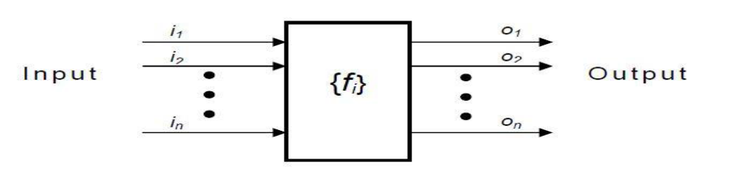

Fig. 3.1: View of a system performing a set of functions

Nonfunctional requirements:-
Nonfunctional requirements deal with the characteristics of the system which cannot be expressed as functions - such as the maintainability of the system, portability of the system, usability of the system, etc.
Goals of implementation:-
The goals of implementation in the SRS documents deal with some general suggestions regarding development. These suggestions guide the trade-off among design’s goals. The goals of implementation section might document issues such as revisions to the system functionalities that may be required in the future, new devices to be supported in the future, reusability issues, etc. These are the items which the developers might keep in their mind during development so that the developed system may meet some aspects that are not required immediately.

Identifying functional requirements from a problem description
The high-level functional requirements often need to be identified either from an informal problem description document or from a conceptual understanding of the problem. Each high-level requirement characterizes a way of system usage by some user to perform some meaningful piece of work. There can be many types of users of a system and their requirements from the system may be very different. So, it is often useful to identify the different types of users who might use the system and then try to identify the requirements from each user’s perspective.
Example: - Consider the case of the library system, where –
F1: Search Book function
Input: an author’s name
Output: details of the author’s books and the location of these books in the library
So the function Search Book (F1) takes the author's name and transforms it into book details.
Functional requirements actually describe a set of high-level requirements, where each high-level requirement takes some data from the user and provides some data to the user as an output. Also each high-level requirement might consist of several other functions.

Documenting functional requirements
In other to document the functional requirements, software engineers need to specify the set of functionalities supported by the system. A function can be specified by identifying the state at which the data is to be input to the system, its input data domain, the output data domain, and the type of processing to be carried on the input data to obtain the output data. Let us first try to document the cash withdrawal function of an Automated Teller Machine (ATM) system. The cash withdrawal is a high-level requirement. It has several sub-requirements corresponding to the different user interactions. These different interaction sequences are captured in different scenarios.
Example: - Withdraw Cash from ATM
R1: withdraw cash
Description: The cash withdrawal function first determines the type of account that the user has and the account number from which the user wishes to withdraw the cash. It checks the balance to determine whether the requested amount is available in the account. If enough balance is available, it outputs the required cash; otherwise it generates an error message.
R1.1 select withdraw amount option
Input: “withdraw amount” option
Output: user prompted to enter the account type
R1.2: select account type
Input: user option
Output: prompt to enter amount
R1.3: get required amount
Input: amount to be withdrawn in integer values greater than 100 and less than 10,000 in multiples of 100.
Output: The requested cash and printed transaction statement.
Processing: the amount is debited from the user’s account if sufficient balance is available, otherwise an error message displayed

Properties of a good SRS document
The important properties of a good SRS document are the following:
• Concise. The SRS document should be concise and at the same time unambiguous, consistent, and complete. Verbose and irrelevant descriptions reduce readability and also increase error possibilities.
• Structured. It should be well-structured. A well-structured document is easy to understand and modify. In practice, the SRS document undergoes several revisions to cope up with the customer requirements. Often, the customer requirements evolve over a period of time. Therefore, in order to make the modifications to the SRS document easy, it is important to make the document well-structured.
• Black-box view. It should only specify what the system should do and refrain from stating how to do these. This means that the SRS document should specify the external behavior of the system and not discuss the implementation issues. The SRS document should view the system to be developed as black box, and should specify the externally visible behavior of the system. For this reason, the SRS document is also called the black-box specification of a system.
• Conceptual integrity. It should show conceptual integrity of the proposed system so that readers can easily understand it.
• Response to undesired events. It should characterize acceptable responses to undesired events. These are called system response to exceptional conditions.
• Verifiable. All requirements of the system as documented in the SRS document should be verifiable. This means that it should be possible to determine whether or not requirements have been met in an implementation.

Problems without a SRS document
The important problems that an organization would face if it does not develop a SRS document are as follows:
• Without developing the SRS document, the system would not be implemented according to customer needs.
• Software developers would not know whether what they are developing is what exactly required by the customer.
• Without SRS document, it will be very much difficult for the maintenance engineers to understand the functionality of the system.
• It will be very much difficult for user-document writers to write the users’ manuals properly without understanding the SRS document.

Problems with an unstructured specification
• It would be very much difficult to understand that document.
• It would be very much difficult to modify that document.
• Conceptual integrity in that document would not be shown.
• The SRS document might be unambiguous and inconsistent.

DECISION TREE
A decision tree gives a graphic view of the processing logic involved in decision making and the corresponding actions (or choices) taken. The edges of a decision tree represent conditions and the leaf nodes represent the actions to be performed depending on the outcome of testing the condition.
Example: -
Consider Library Membership Automation Software (LMS) where it should support the following three options:
• New member
• Renewal
• Cancel membership

New member option-
Decision: When the 'new member' option is selected, the software asks details about the member like the member's name, address, phone number etc.
Action: If proper information is entered then a membership record for the member is created and a bill is printed for the annual membership charge plus the security deposit payable.
Renewal option-
Decision: If the 'renewal' option is chosen, the LMS asks for the member's name and his membership number to check whether he is a valid member or not.
Action: If the membership is valid then membership expiry date is updated and the annual membership bill is printed, otherwise an error message is displayed.
Cancel membership option-
Decision: If the 'cancel membership' option is selected, then the software asks for member's name and his membership number.
Action: The membership is cancelled, a cheque for the balance amount due to the member is printed and finally the membership record is deleted from the database.

The following tree (fig. 3.2) shows the graphical representation of the above example.
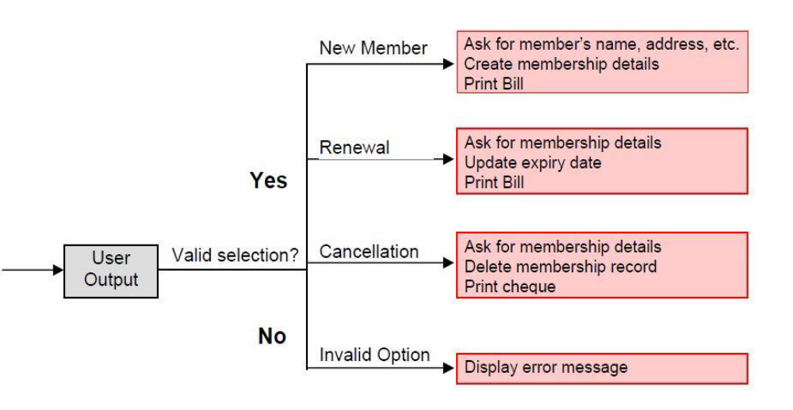

Fig 3.2: Decision Tree of LMS

DECISION TABLE
A decision table is used to represent the complex processing logic in a tabular, chart or a matrix form. The upper rows of the table specify the variables or conditions to be evaluated. The lower rows of the table specify the actions to be taken when the corresponding conditions are satisfied. A column in a table is called a rule. A rule implies that if a condition is true, then the corresponding action is to be executed.
Example: -
Consider the previously discussed LMS example. The following decision table (fig. 3.3) shows how to represent the LMS problem in a tabular form. Here the table is divided into two parts, the upper part shows the conditions and the lower part shows what actions are taken. Each column of the table is a rule.

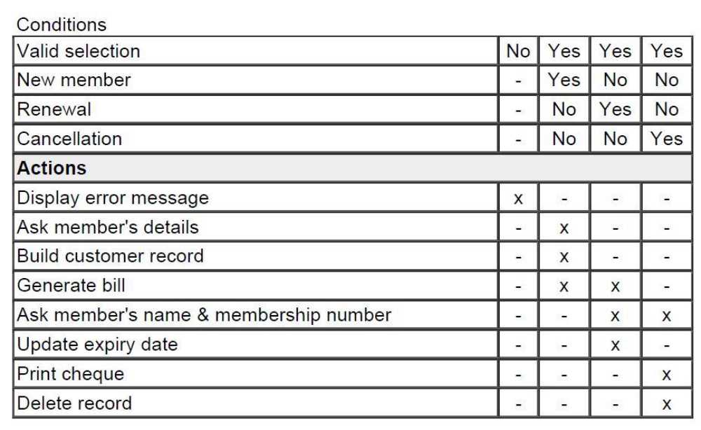

Fig. 3.3: Decision table for LMS
From the above table you can easily understand that, if the valid selection condition is false then the action taken for this condition is 'display error message'. Similarly, the actions taken for other conditions can be inferred from the table.

FORMAL SYSTEM SPECIFICATION
Formal Technique
A formal technique is a mathematical method to specify a hardware and/or software system, verify whether a specification is realizable, verify that an implementation satisfies its specification, prove properties of a system without necessarily running the system, etc. The mathematical basis of a formal method is provided by the specification language.
Formal Specification Language
A formal specification language consists of two sets syn and sem, and a relation sat between them. The set syn is called the syntactic domain, the set sem is called the semantic domain, and the relation sat is called the satisfaction relation. For a given specification syn, and model of the system sem, if sat (syn, sem), then syn is said to be the specification of sem, and sem is said to be the specificand of syn.
Syntactic Domains
The syntactic domain of a formal specification language consists of an alphabet of symbols and set of formation rules to construct well-formed formulas from the alphabet. The well-formed formulas are used to specify a system.
Semantic Domains
Formal techniques can have considerably different semantic domains. Abstract data type specification languages are used to specify algebras, theories, and programs. Programming languages are used to specify functions from input to output values. Concurrent and distributed system specification languages are used to specify state sequences, event sequences, state-transition sequences, synchronization trees, partial orders, state machines, etc.

Satisfaction Relation
Given the model of a system, it is important to determine whether an element of the semantic domain satisfies the specifications. This satisfaction is determined by using a homomorphism known as semantic abstraction function. The semantic abstraction function maps the elements of the semantic domain into equivalent classes. There can be different specifications describing different aspects of a system model, possibly using different specification languages. Some of these specifications describe the system’s behavior and the others describe the system’s structure. Consequently, two broad classes of semantic abstraction functions are defined: those that preserve a system’s behavior and those that preserve a system’s structure.
Model-oriented vs. property-oriented approaches
Formal methods are usually classified into two broad categories – model – oriented and property – oriented approaches. In a model-oriented style, one defines a system’s behavior directly by constructing a model of the system in terms of mathematical structures such as tuples, relations, functions, sets, sequences, etc.
In the property-oriented style, the system's behavior is defined indirectly by stating its properties, usually in the form of a set of axioms that the system must satisfy.
Example:-
Let us consider a simple producer/consumer example. In a property-oriented style, it is probably started by listing the properties of the system like: the consumer can start consuming only after the producer has produced an item; the producer starts to produce an item only after the consumer has consumed the last item, etc. A good example of a producer-consumer problem is CPU-Printer coordination. After processing of data, CPU outputs characters to the buffer for printing. Printer, on the other hand, reads characters from the buffer and prints them. The CPU is constrained by the capacity of the buffer, whereas the printer is constrained by an empty buffer. Examples of property-oriented specification styles are axiomatic specification and algebraic specification.
In a model-oriented approach, we start by defining the basic operations, p (produce) and c (consume). Then we can state that S1 + p → S, S + c → S1. Thus the model-oriented approaches essentially specify a program by writing another, presumably simpler program. Examples of popular model-oriented specification techniques are Z, CSP, CCS, etc.
Model-oriented approaches are more suited to use in later phases of life cycle because here even minor changes to a specification may lead to drastic changes to the entire specification. They do not support logical conjunctions (AND) and disjunctions (OR).
Property-oriented approaches are suitable for requirements specification because they can be easily changed. They specify a system as a conjunction of axioms and you can easily replace one axiom with another one.
Operational Semantics
Informally, the operational semantics of a formal method is the way computations are represented. There are different types of operational semantics according to what is meant by a single run of the system and how the runs are grouped together to describe the behavior of the system. Some commonly used operational semantics are as follows:
Linear Semantics:-
In this approach, a run of a system is described by a sequence (possibly infinite) of events or states. The concurrent activities of the system are represented by non-deterministic inter-leavings of the automatic actions. For example, a concurrent activity a║b is represented by the set of
sequential activities a;b and b;a. This is simple but rather unnatural representation of concurrency. The behavior of a system in this model consists of the set of all its runs. To make this model realistic, usually justice and fairness restrictions are imposed on computations to exclude the unwanted inter-leavings.
Branching Semantics:-
In this approach, the behavior of a system is represented by a directed graph. The nodes of the graph represent the possible states in the evolution of a system. The descendants of each node of the graph represent the states which can be generated by any of the atomic actions enabled at that state. Although this semantic model distinguishes the branching points in a computation, still it represents concurrency by interleaving.
Maximally parallel semantics:-
In this approach, all the concurrent actions enabled at any state are assumed to be taken together. This is again not a natural model of concurrency since it implicitly assumes the availability of all the required computational resources.
Partial order semantics:-
Under this view, the semantics ascribed to a system is a structure of states satisfying a partial order relation among the states (events). The partial order represents a precedence ordering among events, and constraints some events to occur only after some other events have occurred; while the occurrence of other events (called concurrent events) is considered to be incomparable. This fact identifies concurrency as a phenomenon not translatable to any interleaved representation.
Formal methods possess several positive features, some of which are discussed below.
• Formal specifications encourage rigor. Often, the very process of construction of a rigorous specification is more important than the formal specification itself. The construction of a rigorous specification clarifies several aspects of system behavior that are not obvious in an informal specification.
• Formal methods usually have a well-founded mathematical basis. Thus, formal specifications are not only more precise, but also mathematically sound and can be used to reason about the properties of a specification and to rigorously prove that an implementation satisfies its specifications.
• Formal methods have well-defined semantics. Therefore, ambiguity in specifications is automatically avoided when one formally specifies a system.
• The mathematical basis of the formal methods facilitates automating the analysis of specifications. For example, a tableau-based technique has been used to automatically check the consistency of specifications. Also, automatic theorem proving techniques can be used to verify that an implementation satisfies its specifications. The possibility of automatic verification is one of the most important advantages of formal methods.
• Formal specifications can be executed to obtain immediate feedback on the features of the specified system. This concept of executable specifications is related to rapid prototyping. Informally, a prototype is a “toy” working model of a system that can provide immediate feedback on the behavior of the specified system, and is especially useful in checking the completeness of specifications.
Limitations of formal requirements specification
It is clear that formal methods provide mathematically sound frameworks within large, complex systems can be specified, developed and verified in a systematic rather than in an ad hoc manner. However, formal methods suffer from several shortcomings, some of which are the following:
• Formal methods are difficult to learn and use.

• The basic incompleteness results of first-order logic suggest that it is impossible to check absolute correctness of systems using theorem proving techniques.
• Formal techniques are not able to handle complex problems. This shortcoming results from the fact that, even moderately complicated problems blow up the complexity of formal specification and their analysis. Also, a large unstructured set of mathematical formulas is difficult to comprehend.

Axiomatic Specification
In axiomatic specification of a system, first-order logic is used to write the pre and post-conditions to specify the operations of the system in the form of axioms. The pre-conditions basically capture the conditions that must be satisfied before an operation can successfully be invoked. In essence, the pre-conditions capture the requirements on the input parameters of a function. The post-conditions are the conditions that must be satisfied when a function completes execution for the function to be considered to have executed successfully. Thus, the post-conditions are essentially constraints on the results produced for the function execution to be considered successful.

The following are the sequence of steps that can be followed to systematically develop the axiomatic specifications of a function:
• Establish the range of input values over which the function should behave correctly. Also find out other constraints on the input parameters and write it in the form of a predicate.
• Specify a predicate defining the conditions which must hold on the output of the function if it behaved properly.

• Establish the changes made to the function’s input parameters after execution of the function. Pure mathematical functions do not change their input and therefore this type of assertion is not necessary for pure functions.
• Combine all of the above into pre and post conditions of the function.

Example1: -
Specify the pre- and post-conditions of a function that takes a real number as argument and returns half the input value if the input is less than or equal to 100, or else returns double the value.
f (x : real) : real
pre : x ∈ R
post : {(x≤100) ∧ (f(x) = x/2)} ∨ {(x>100) ∧ (f(x) = 2∗x)}
Example2: -
Axiomatically specify a function named search which takes an integer array and an integer key value as its arguments and returns the index in the array where the key value is present.
search(X : IntArray, key : Integer) : Integer
pre :∃i∈ [Xfirst….Xlast], X[i] = key
post : {(X′[search(X, key)] = key) ∧ (X = X′)}
Here the convention followed is: If a function changes any of its input parameters and if that parameter is named X, and then it is referred to as X′ after the function completes execution faster.

Module 4

4. SOFTWARE DESIGN
Software design is a process to transform user requirements into some suitable form, which helps the programmer in software coding and implementation.
For assessing user requirements, an SRS (Software Requirement Specification) document is created whereas for coding and implementation, there is a need of more specific and detailed requirements in software terms. The output of this process can directly be used into implementation in programming languages.
Software design is the first step in SDLC (Software Design Life Cycle), which moves the concentration from problem domain to solution domain. It tries to specify how to fulfill the requirements mentioned in SRS.

Software Design Levels
Software design yields three levels of results:
• Architectural Design - The architectural design is the highest abstract version of the system. It identifies the software as a system with many components interacting with each other. At this level, the designers get the idea of proposed solution domain.
• High-level Design- The high-level design breaks the ‘single entity-multiple component’ concept of architectural design into less-abstracted view of sub-systems and modules and depicts their interaction with each other. High-level design focuses on how the system along with all of its components can be implemented in forms of modules. It recognizes modular structure of each sub-system and their relation and interaction among each other.
• Detailed Design- Detailed design deals with the implementation part of what is seen as a system and its sub-systems in the previous two designs. It is more detailed towards modules and their implementations. It defines logical structure of each module and their interfaces to communicate with other modules.

Modularization
Modularization is a technique to divide a software system into multiple discrete and independent modules, which are expected to be capable of carrying out task(s) independently. These modules may work as basic constructs for the entire software. Designers tend to design modules such that they can be executed and/or compiled separately and independently.
Modular design unintentionally follows the rules of ‘divide and conquer’ problem-solving strategy this is because there are many other benefits attached with the modular design of a software.

Advantage of modularization:
• Smaller components are easier to maintain
• Program can be divided based on functional aspects
• Desired level of abstraction can be brought in the program
• Components with high cohesion can be re-used again.
• Concurrent execution can be made possible
• Desired from security aspect

Concurrency
Back in time, all softwares were meant to be executed sequentially. By sequential execution we mean that the coded instruction will be executed one after another implying only one portion of program being activated at any given time. Say, a software has multiple modules, then only one of all the modules can be found active at any time of execution.
In software design, concurrency is implemented by splitting the software into multiple independent units of execution, like modules and executing them in parallel. In other words, concurrency provides capability to the software to execute more than one part of code in parallel to each other.
It is necessary for the programmers and designers to recognize those modules, which can be made parallel execution.
Example
The spell check feature in word processor is a module of software, which runs alongside the word processor itself.
Coupling and Cohesion
When a software program is modularized, its tasks are divided into several modules based on some characteristics. As we know, modules are set of instructions put together in order to achieve some tasks. They are though, considered as single entity but may refer to each other to work together. There are measures by which the quality of a design of modules and their interaction among them can be measured. These measures are called coupling and cohesion.
Cohesion
Cohesion is a measure that defines the degree of intra-dependability within elements of a module. The greater the cohesion, the better is the program design.

There are seven types of cohesion, namely –
• Co-incidental cohesion - It is unplanned and random cohesion, which might be the result of breaking the program into smaller modules for the sake of modularization. Because it is unplanned, it may serve confusion to the programmers and is generally not-accepted.
• Logical cohesion - When logically categorized elements are put together into a module, it is called logical cohesion.
• Temporal Cohesion - When elements of module are organized such that they are processed at a similar point in time, it is called temporal cohesion.
• Procedural cohesion - When elements of module are grouped together, which are executed sequentially in order to perform a task, it is called procedural cohesion.
• Communicational cohesion - When elements of module are grouped together, which are executed sequentially and work on same data (information), it is called communicational cohesion.
• Sequential cohesion - When elements of module are grouped because the output of one element serves as input to another and so on, it is called sequential cohesion.
• Functional cohesion - It is considered to be the highest degree of cohesion, and it is highly expected. Elements of module in functional cohesion are grouped because they all contribute to a single well-defined function. It can also be reused.

Coupling
Coupling is a measure that defines the level of inter-dependability among modules of a program. It tells at what level the modules interfere and interact with each other. The lower the coupling, the better the program.
There are five levels of coupling, namely -
• Content coupling - When a module can directly access or modify or refer to the content of another module, it is called content level coupling.
• Common coupling- When multiple modules have read and write access to some global data, it is called common or global coupling.
• Control coupling- Two modules are called control-coupled if one of them decides the function of the other module or changes its flow of execution.
• Stamp coupling- When multiple modules share common data structure and work on different part of it, it is called stamp coupling.
• Data coupling- Data coupling is when two modules interact with each other by means of passing data (as parameter). If a module passes data structure as parameter, then the receiving module should use all its components.

Ideally, no coupling is considered to be the best.
Design Verification
The output of software design process is design documentation, pseudo codes, detailed logic diagrams, process diagrams, and detailed description of all functional or non-functional requirements.
The next phase, which is the implementation of software, depends on all outputs mentioned above.
It is then becomes necessary to verify the output before proceeding to the next phase. The early any mistake is detected, the better it is or it might not be detected until testing of the product. If the outputs of design phase are in formal notation form, then their associated tools for verification should be used otherwise a thorough design review can be used for verification and validation.
By structured verification approach, reviewers can detect defects that might be caused by overlooking some conditions. A good design review is important for good software design, accuracy and quality.

SOFTWARE DESIGN STRATEGIES
Software design is a process to conceptualize the software requirements into software implementation. Software design takes the user requirements as challenges and tries to find optimum solution. While the software is being conceptualized, a plan is chalked out to find the best possible design for implementing the intended solution.
There are multiple variants of software design. Let us study them briefly:
Software design is a process to conceptualize the software requirements into software implementation. Software design takes the user requirements as challenges and tries to find optimum solution. While the software is being conceptualized, a plan is chalked out to find the best possible design for implementing the intended solution.
There are multiple variants of software design. Let us study them briefly:

Structured Design
Structured design is a conceptualization of problem into several well-organized elements of solution. It is basically concerned with the solution design. Benefit of structured design is, it gives better understanding of how the problem is being solved. Structured design also makes it simpler for designer to concentrate on the problem more accurately.
Structured design is mostly based on ‘divide and conquer’ strategy where a problem is broken into several small problems and each small problem is individually solved until the whole problem is solved.
The small pieces of problem are solved by means of solution modules. Structured design emphasis that these modules be well organized in order to achieve precise solution.
These modules are arranged in hierarchy. They communicate with each other. A good structured design always follows some rules for communication among multiple modules, namely -
Cohesion - grouping of all functionally related elements.
Coupling - communication between different modules.
A good structured design has high cohesion and low coupling arrangements.

Function Oriented Design
In function-oriented design, the system is comprised of many smaller sub-systems known as functions. These functions are capable of performing significant task in the system. The system is considered as top view of all functions.
Function oriented design inherits some properties of structured design where divide and conquer methodology is used.
This design mechanism divides the whole system into smaller functions, which provides means of abstraction by concealing the information and their operation. These functional modules can share information among themselves by means of information passing and using information available globally.
Another characteristic of functions is that when a program calls a function, the function changes the state of the program, which sometimes is not acceptable by other modules. Function oriented design works well where the system state does not matter and program/functions work on input rather than on a state.

Design Process
• The whole system is seen as how data flows in the system by means of data flow diagram.
• DFD depicts how functions change the data and state of entire system.
• The entire system is logically broken down into smaller units known as functions on the basis of their operation in the system.
• Each function is then described at large.

Object Oriented Design
Object oriented design works around the entities and their characteristics instead of functions involved in the software system. This design strategy focuses on entities and its characteristics. The whole concept of software solution revolves around the engaged entities.
Let us see the important concepts of Object Oriented Design:
• Objects - All entities involved in the solution design are known as objects. For example, person, banks, company and customers are treated as objects. Every entity has some attributes associated to it and has some methods to perform on the attributes.
• Classes - A class is a generalized description of an object. An object is an instance of a class. Class defines all the attributes, which an object can have and methods, which defines the functionality of the object.

In the solution design, attributes are stored as variables and functionalities are defined by means of methods or procedures.
• Encapsulation - In OOD, the attributes (data variables) and methods (operation on the data) are bundled together is called encapsulation. Encapsulation not only bundles important information of an object together, but also restricts access of the data and methods from the outside world. This is called information hiding.
• Inheritance - OOD allows similar classes to stack up in hierarchical manner where the lower or sub-classes can import, implement and re-use allowed variables and methods from their immediate super classes. This property of OOD is known as inheritance. This makes it easier to define specific class and to create generalized classes from specific ones.
• Polymorphism - OOD languages provide a mechanism where methods performing similar tasks but vary in arguments, can be assigned same name. This is called polymorphism, which allows a single interface performing tasks for different types. Depending upon how the function is invoked, respective portion of the code gets executed.

Design Process
Software design process can be perceived as series of well-defined steps. Though it varies according to design approach (function oriented or object oriented, yet It may have the following steps involved:
• A solution design is created from requirement or previous used system and/or system sequence diagram.
• Objects are identified and grouped into classes on behalf of similarity in attribute characteristics.
• Class hierarchy and relation among them are defined.
• Application framework is defined.

Software Design Approaches
There are two generic approaches for software designing:
Top down Design and Bottom up design
We know that a system is composed of more than one sub-systems and it contains a number of components. Further, these sub-systems and components may have their one set of sub-system and components and creates hierarchical structure in the system.

Top-down design
Top-down design takes the whole software system as one entity and then decomposes it to achieve more than one sub-system or component based on some characteristics. Each sub-system or component is then treated as a system and decomposed further. This process keeps on running until the lowest level of system in the top-down hierarchy is achieved.
Top-down design starts with a generalized model of system and keeps on defining the more specific part of it. When all components are composed the whole system comes into existence.
Top-down design is more suitable when the software solution needs to be designed from scratch and specific details are unknown.

Bottom-up Design
The bottom up design model starts with most specific and basic components. It proceeds with composing higher level of components by using basic or lower level components. It keeps creating higher level components until the desired system is not evolved as one single component. With each higher level, the amount of abstraction is increased.
Bottom-up strategy is more suitable when a system needs to be created from some existing system, where the basic primitives can be used in the newer system.
Both, top-down and bottom-up approaches are not practical individually. Instead, a good combination of both is used.

SOFTWARE ANALYSIS & DESIGN TOOLS
Software analysis and design includes all activities, which help the transformation of requirement specification into implementation. Requirement specifications specify all functional and non-functional expectations from the software. These requirement specifications come in the shape of human readable and understandable documents, to which a computer has nothing to do.
Software analysis and design is the intermediate stage, which helps human-readable requirements to be transformed into actual code.
Let us see few analysis and design tools used by software designers:

Data Flow Diagram (DFD)
Data flow diagram is a graphical representation of data flow in an information system. It is capable of depicting incoming data flow, outgoing data flow and stored data. The DFD does not mention anything about how data flows through the system.
There is a prominent difference between DFD and Flowchart. The flowchart depicts flow of control in program modules. DFDs depict flow of data in the system at various levels. DFD does not contain any control or branch elements.
Types of DFD
Data Flow Diagrams are either Logical or Physical.
• Logical DFD - This type of DFD concentrates on the system process and flow of data in the system. For example in a Banking software system, how data is moved between different entities.
• Physical DFD - This type of DFD shows how the data flow is actually implemented in the system. It is more specific and close to the implementation.

DFD Components
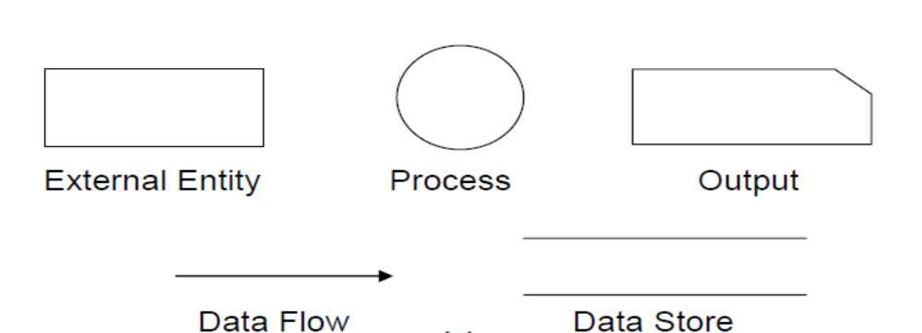
DFD can represent Source, destination, storage and flow of data using the following set of components

Fig 4.1: DFD Components

• Entities - Entities are source and destination of information data. Entities are represented by rectangles with their respective names.
• Process - Activities and action taken on the data are represented by Circle or Round-edged rectangles.
• Data Storage - There are two variants of data storage - it can either be represented as a rectangle with absence of both smaller sides or as an open-sided rectangle with only one side missing.
• Data Flow - Movement of data is shown by pointed arrows. Data movement is shown from the base of arrow as its source towards head of the arrow as destination.

Importance of DFDs in a good software design
The main reason why the DFD technique is so popular is probably because of the fact that DFD is a very simple formalism – it is simple to understand and use. Starting with a set of high-level functions that a system performs, a DFD model hierarchically represents various sub-functions. In fact, any hierarchical model is simple to understand. Human mind is such that it can easily understand any hierarchical model of a system – because in a hierarchical model, starting with a very simple and abstract model of a system, different details of the system are slowly introduced through different hierarchies. The data flow diagramming technique also follows a very simple set of intuitive concepts and rules. DFD is an elegant modeling technique that turns out to be useful not only to represent the results of structured analysis of a software problem, but also for several other applications such as showing the flow of documents or items in an organization.

Data Dictionary
A data dictionary lists all data items appearing in the DFD model of a system. The data items listed include all data flows and the contents of all data stores appearing on the DFDs in the DFD model of a system. A data dictionary lists the purpose of all data items and the definition of all composite data items in terms of their component data items. For example, a data dictionary entry may represent that the data grossPay consists of the components regularPay and overtimePay.
grossPay = regularPay + overtimePay
For the smallest units of data items, the data dictionary lists their name and their type. Composite data items can be defined in terms of primitive data items using the following data definition operators:
+: denotes composition of two data items, e.g. a+brepresents data a andb.
[,,]: represents selection, i.e. any one of the data items listed in the brackets can occur. For example, [a,b] represents either a occurs or b occurs.
(): the contents inside the bracket represent optional data which may or may not appear. e.g. a+(b) represents either a occurs or a+boccurs.
{}: represents iterative data definition, e.g. {name}5represents five name data. {name}* represents zero or more instances of name data.
=: represents equivalence, e.g. a=b+cmeans that a represents b and c.
/* */: Anything appearing within /* and */ is considered as a comment.
Example 1: Tic-Tac-Toe Computer Game
Tic-tac-toe is a computer game in which a human player and the computer make alternative moves on a 3×3 square. A move consists of marking previously unmarked square. The player who first places three consecutive marks along a straight line on the square (i.e. along a row, column, or diagonal) wins the game. As soon as either the human player or the computer wins, a message congratulating the winner should be displayed. If neither player manages to get three consecutive marks along a straight line, but all the squares on the board are filled up, then the game is drawn. The computer always tries to win a game.
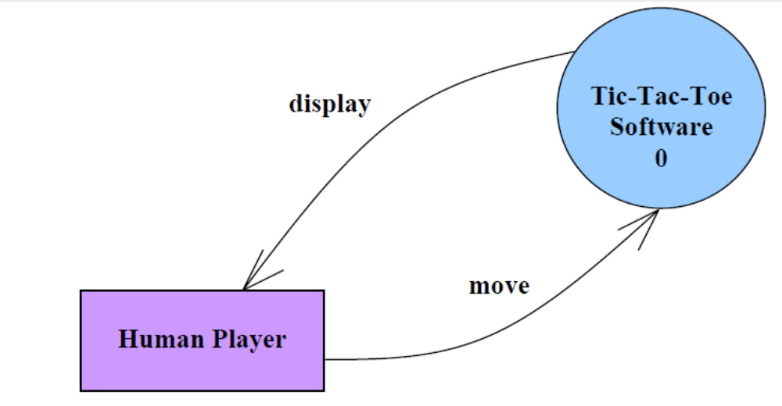

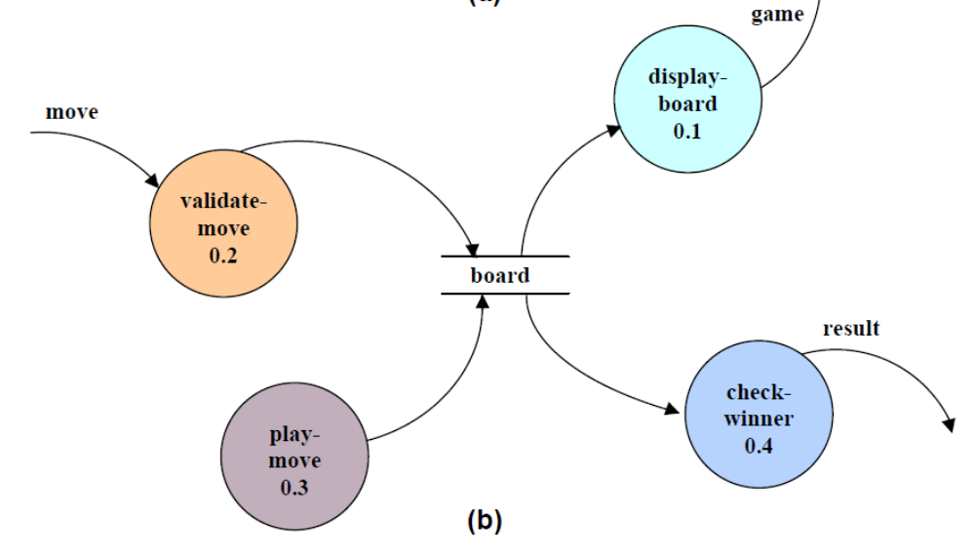

Fig 4.2 (a) Level 0 (b) Level 1 DFD for Tic-Tac-Toe game

It may be recalled that the DFD model of a system typically consists of several DFDs: level 0, level 1, etc. However, a single data dictionary should capture all the data appearing in all the DFDs constituting the model. Figure 4.2 represents the level 0 and level 1 DFDs for the tic-tac-toe game. The data dictionary for the model is given below.
Data Dictionary for the DFD model in Example 1
move: integer /*number between 1 and 9 */
display: game+result
game: board
board: {integer}9
result: [“computer won”, “human won” “draw”]
Importance of Data Dictionary
A data dictionary plays a very important role in any software development process because of the following reasons:
• A data dictionary provides a standard terminology for all relevant data for use by the engineers working in a project. A consistent vocabulary for data items is very important, since in large projects different engineers of the project have a tendency to use different terms to refer to the same data, which unnecessary causes confusion.
• The data dictionary provides the analyst with a means to determine the definition of different data structures in terms of their component elements.
Balancing a DFD
The data that flow into or out of a bubble must match the data flow at the next level of DFD. This is known as balancing a DFD. The concept of balancing a DFD has been illustrated in fig. 10.3. In the level 1 of the DFD, data items d1 and d3 flow out of the bubble 0.1 and the data item d2 flows into the bubble 0.1. In the next level, bubble 0.1 is decomposed. The decomposition is balanced, as d1 and d3 flow out of the level 2 diagram and d2 flows in.
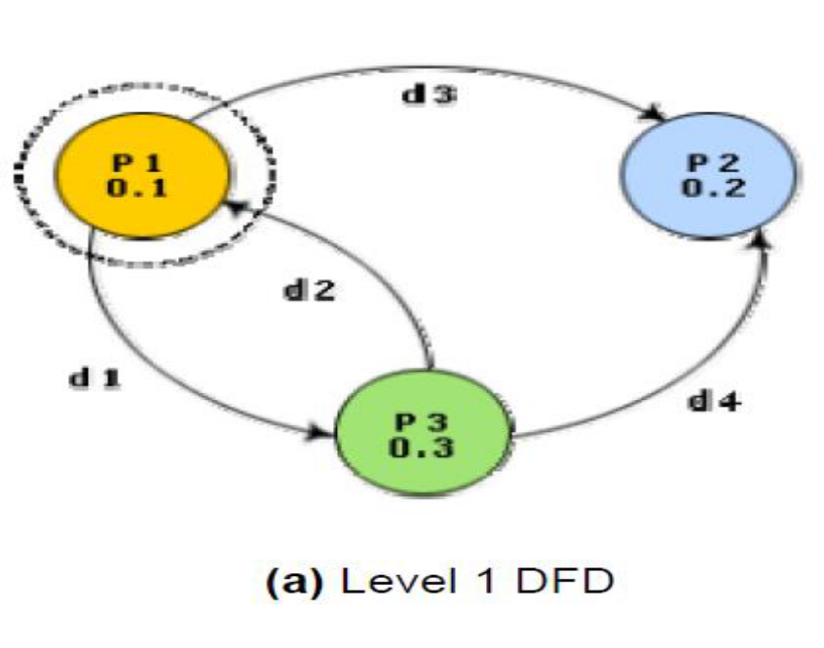

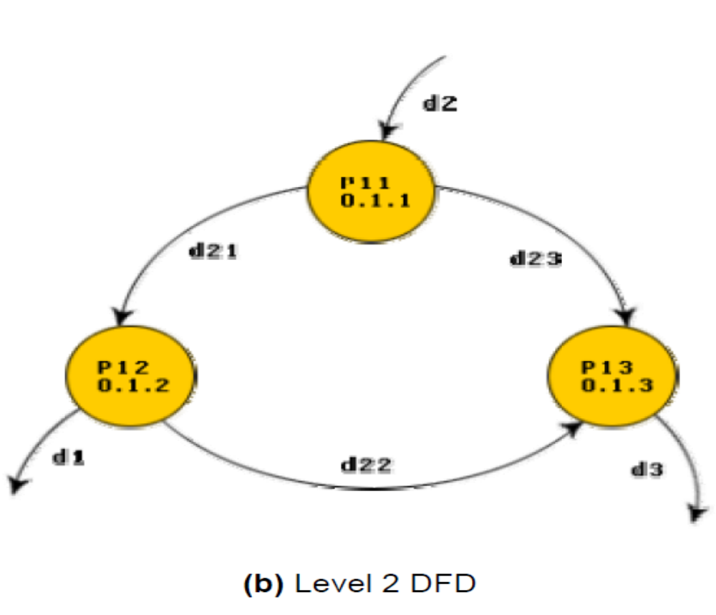

Fig. 4.3: An example showing balanced decomposition

Context Diagram
The context diagram is the most abstract data flow representation of a system. It represents the entire system as a single bubble. This bubble is labeled according to the main function of the system. The various external entities with which the system interacts and the data flow occurring between the system and the external entities are also represented. The data input to the system and the data output from the system are represented as incoming and outgoing arrows. These data flow arrows should be annotated with the corresponding data names. The name ‘context diagram’ is well justified because it represents the context in which the system is to exist, i.e. the external entities who would interact with the system and the specific data items they would be supplying the system and the data items they would be receiving from the system. The context diagram is also called as the level 0 DFD.
To develop the context diagram of the system, it is required to analyze the SRS document to identify the different types of users who would be using the system and the kinds of data they would be inputting to the system and the data they would be receiving the system. Here, the term “users of the system” also includes the external systems which supply data to or receive data from the system.
The bubble in the context diagram is annotated with the name of the software system being developed (usually a noun). This is in contrast with the bubbles in all other levels which are annotated with verbs. This is expected since the purpose of the context diagram is to capture the context of the system rather than its functionality.
Example 1: RMS Calculating Software.
A software system called RMS calculating software would read three integral numbers from the user in the range of -1000 and +1000 and then determine the root mean square (rms) of the three input numbers and display it. In this example, the context diagram (fig. 10.4) is simple to draw. The system accepts three integers from the user and returns the result to him.

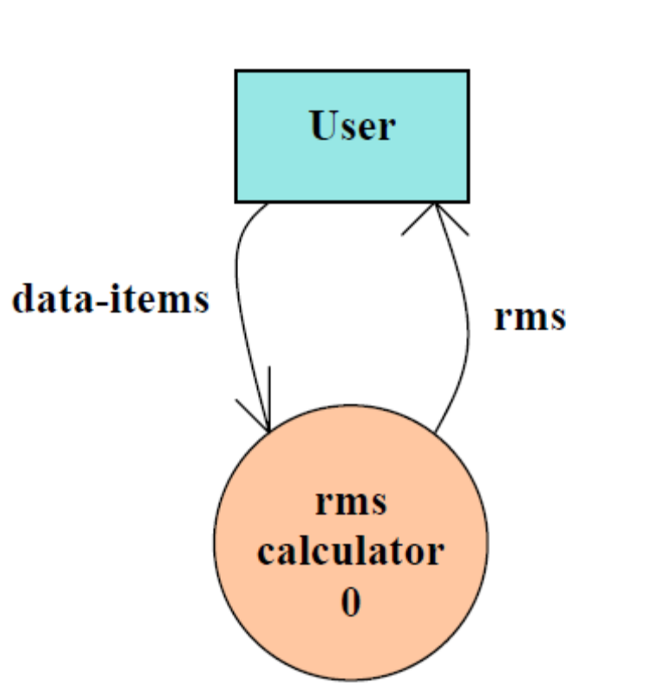

Fig. 4.4: Context Diagram
To develop the data flow model of a system, first the most abstract representation of the problem is to be worked out. The most abstract representation of the problem is also called the context diagram. After, developing the context diagram, the higher-level DFDs have to be developed.
Context Diagram: - This has been described earlier.
Level 1 DFD: - To develop the level 1 DFD, examine the high-level functional requirements. If there are between 3 to 7 high-level functional requirements, then these can be directly represented as bubbles in the level 1 DFD. We can then examine the input data to these functions and the data output by these functions and represent them appropriately in the diagram.
If a system has more than 7 high-level functional requirements, then some of the related requirements have to be combined and represented in the form of a bubble in the level 1 DFD. Such a bubble can be split in the lower DFD levels. If a system has less than three high-level functional requirements, then some of them need to be split into their sub-functions so that we have roughly about 5 to 7 bubbles on the diagram.
Decomposition:-
Each bubble in the DFD represents a function performed by the system. The bubbles are decomposed into sub-functions at the successive levels of the DFD. Decomposition of a bubble is also known as factoring or exploding a bubble. Each bubble at any level of DFD is usually decomposed to anything between 3 to 7 bubbles. Too few bubbles at any level make that level superfluous. For example, if a bubble is decomposed to just one bubble or two bubbles, then this decomposition becomes redundant. Also, too many bubbles, i.e. more than 7 bubbles at any level of a DFD makes the DFD model hard to understand. Decomposition of a bubble should be carried on until a level is reached at which the function of the bubble can be described using a simple algorithm.
Numbering of Bubbles:-
It is necessary to number the different bubbles occurring in the DFD. These numbers help in uniquely identifying any bubble in the DFD by its bubble number. The bubble at the context level is usually assigned the number 0 to indicate that it is the 0 level DFD. Bubbles at level 1 are numbered, 0.1, 0.2, 0.3, etc, etc. When a bubble numbered x is decomposed, its children bubble are numbered x.1, x.2, x.3, etc. In this numbering scheme, by looking at the number of a bubble we can unambiguously determine its level, its ancestors, and its successors.
Example:-
A supermarket needs to develop the following software to encourage regular customers. For this, the customer needs to supply his/her residence address, telephone number, and the driving license number. Each customer who registers for this scheme is assigned a unique customer number (CN) by the computer. A customer can present his CN to the check out staff when he makes any purchase. In this case, the value of his purchase is credited against his CN. At the end of each year, the supermarket intends to award surprise gifts to 10 customers who make the highest total purchase over the year. Also, it intends to award a 22 caret gold coin to every customer whose purchase exceeded Rs.10,000. The entries against the CN are the reset on the day of every year after the prize winners’ lists are generated.
The context diagram for this problem is shown in fig. 10.5, the level 1 DFD in fig. 10.6, and the level 2 DFD in Fig. 4.4.
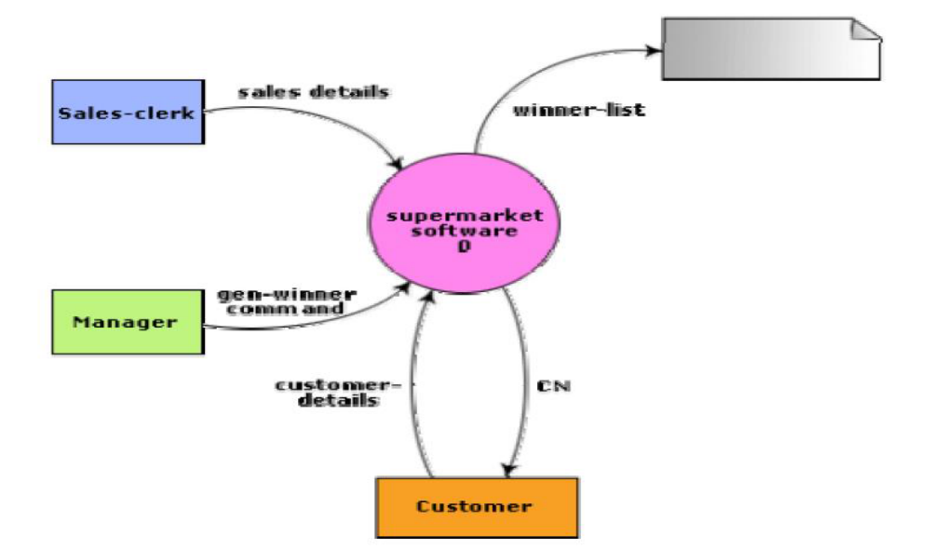

Fig. 4.4: Context diagram for supermarket problem

STRUCTURED DESIGN
The aim of structured design is to transform the results of the structured analysis (i.e. a DFD representation) into a structure chart. Structured design provides two strategies to guide transformation of a DFD into a structure chart.
• Transform analysis
• Transaction analysis
Normally, one starts with the level 1 DFD, transforms it into module representation using either the transform or the transaction analysis and then proceeds towards the lower-level DFDs. At each level of transformation, it is important to first determine whether the transform or the transaction analysis is applicable to a particular DFD. These are discussed in the subsequent sub-sections.
Structure Chart
A structure chart represents the software architecture, i.e. the various modules making up the system, the dependency (which module calls which other modules), and the parameters that are passed among the different modules. Hence, the structure chart representation can be easily implemented using some programming language. Since the main focus in a structure chart representation is on the module structure of the software and the interactions among different modules, the procedural aspects (e.g. how a particular functionality is achieved) are not represented.
The basic building blocks which are used to design structure charts are the following:
• Rectangular boxes: Represents a module.
• Module invocation arrows: Control is passed from on one module to another module in the direction of the connecting arrow.
• Data flow arrows: Arrows are annotated with data name; named data passes from one module to another module in the direction of the arrow.
• Library modules: Represented by a rectangle with double edges.
• Selection: Represented by a diamond symbol.
• Repetition: Represented by a loop around the control flow arrow.

Structure Chart vs. Flow Chart
We are all familiar with the flow chart representation of a program. Flow chart is a convenient technique to represent the flow of control in a program. A structure chart differs from a flow chart in three principal ways:

• It is usually difficult to identify the different modules of the software from its flow chart representation.
• Data interchange among different modules is not represented in a flow chart.
• Sequential ordering of tasks inherent in a flow chart is suppressed in a structure chart.
Transform Analysis
Transform analysis identifies the primary functional components (modules) and the high level inputs and outputs for these components. The first step in transform analysis is to divide the DFD into 3 types of parts:
• Input
• Logical processing
• Output
The input portion of the DFD includes processes that transform input data from physical (e.g. character from terminal) to logical forms (e.g. internal tables, lists, etc.). Each input portion is called an afferent branch.
The output portion of a DFD transforms output data from logical to physical form. Each output portion is called an efferent branch. The remaining portion of a DFD is called the central transform.
In the next step of transform analysis, the structure chart is derived by drawing one functional component for the central transform, and the afferent and efferent branches.
These are drawn below a root module, which would invoke these modules. Identifying the highest level input and output transforms requires experience and skill. One possible approach is to trace the inputs until a bubble is found whose output cannot be deduced from its inputs alone. Processes which validate input or add information to them are not central transforms. Processes which sort input or filter data from it are. The first level structure chart is produced by representing each input and output unit as boxes and each central transform as a single box. In the third step of transform analysis, the structure chart is refined by adding sub-functions required by each of the high-level functional components. Many levels of functional components may be added. This process of breaking functional components into subcomponents is called factoring. Factoring includes adding read and write modules, error-handling modules, initialization and termination process, identifying customer modules, etc. The factoring process is continued until all bubbles in the DFD are represented in the structure chart.

OBJECT MODELLING USING UML
Model
A model captures aspects important for some application while omitting (or abstracting) the rest. A model in the context of software development can be graphical, textual, mathematical, or program code-based. Models are very useful in documenting the design and analysis results. Models also facilitate the analysis and design procedures themselves. Graphical models are very popular because they are easy to understand and construct. UML is primarily a graphical modeling tool. However, it often requires text explanations to accompany the graphical models.
Need for a model
An important reason behind constructing a model is that it helps manage complexity. Once models of a system have been constructed, these can be used for a variety of purposes during software development, including the following:
• Analysis
• Specification
• Code generation
• Design
• Visualize and understand the problem and the working of a system
• Testing, etc.
In all these applications, the UML models can not only be used to document the results but also to arrive at the results themselves. Since a model can be used for a variety of purposes, it is reasonable to expect that the model would vary depending on the purpose for which it is being constructed. For example, a model developed for initial analysis and specification should be very different from the one used for design. A model that is being used for analysis and specification would not show any of the design decisions that would be made later on during the design stage. On the other hand, a model used for design purposes should capture all the design decisions. Therefore, it is a good idea to explicitly mention the purpose for which a model has been developed, along with the model.

Unified Modeling Language (UML)
UML, as the name implies, is a modeling language. It may be used to visualize, specify, construct, and document the artifact of a software system. It provides a set of notations (e.g. rectangles, lines, ellipses, etc.) to create a visual model of the system. Like any other language, UML has its own syntax (symbols and sentence formation rules) and semantics (meanings of symbols and sentences). Also, we should clearly understand that UML is not a system design or development methodology, but can be used to document object-oriented and analysis results obtained using some methodology.
Origin of UML
In the late 1980s and early 1990s, there was a proliferation of object-oriented design techniques and notations. Different software development houses were using different notations to document their object-oriented designs. These diverse notations used to give rise to a lot of confusion.
UML was developed to standardize the large number of object-oriented modeling notations that existed and were used extensively in the early 1990s. The principles ones in use were:
• Object Management Technology [Rumbaugh 1991]
• Booch’s methodology [Booch 1991]
• Object-Oriented Software Engineering [Jacobson 1992]
• Odell’s methodology [Odell 1992]
• Shaler and Mellor methodology [Shaler 1992]
It is needless to say that UML has borrowed many concepts from these modeling techniques. Especially, concepts from the first three methodologies have been heavily drawn upon. UML was adopted by Object Management Group (OMG) as a de facto standard in 1997. OMG is an association of industries which tries to facilitate early formation of standards.
We shall see that UML contains an extensive set of notations and suggests construction of many types of diagrams. It has successfully been used to model both large and small problems. The elegance of UML, its adoption by OMG, and a strong industry backing have helped UML find widespread acceptance. UML is now being used in a large number of software development projects worldwide.

UML Diagrams
UML can be used to construct nine different types of diagrams to capture five different views of a system. Just as a building can be modeled from several views (or perspectives) such as ventilation perspective, electrical perspective, lighting perspective, heating perspective, etc.; the different UML diagrams provide different perspectives of the software system to be developed and facilitate a comprehensive understanding of the system. Such models can be refined to get the actual implementation of the system.
The UML diagrams can capture the following five views of a system:
• User’s view
• Structural view
• Behavioral view
• Implementation view
• Environmental view

User’s view: This view defines the functionalities (facilities) made available by the system to its users. The users’ view captures the external users’ view of the system in terms of the functionalities offered by the system. The users’ view is a black-box view of the system where the internal structure, the dynamic behavior of different system components, the implementation etc. are not visible. The users’ view is very different from all other views in the sense that it is a functional model compared to the object model of all other views. The users’ view can be considered as the central view and all other views are expected to conform to this view. This thinking is in fact the crux of any user centric development style.
Structural view: The structural view defines the kinds of objects (classes) important to the understanding of the working of a system and to its implementation. It also captures the relationships among the classes (objects). The structural model is also called the static model, since the structure of a system does not change with time.
Behavioral view: The behavioral view captures how objects interact with each other to realize the system behavior. The system behavior captures the time-dependent (dynamic) behavior of the system.
Implementation view: This view captures the important components of the system and their dependencies.
Environmental view: This view models how the different components are implemented on different pieces of hardware.

USE CASE DIAGRAM
Use Case Model
The use case model for any system consists of a set of “use cases”. Intuitively, use cases represent the different ways in which a system can be used by the users. A simple way to find all the use cases of a system is to ask the question: “What the users can do using the system?” Thus for the Library Information System (LIS), the use cases could be:
• issue-book
• query-book
• return-book
• create-member
• add-book, etc
Use cases correspond to the high-level functional requirements. The use cases partition the system behavior into transactions, such that each transaction performs some useful action from the user’s point of view. To complete each transaction may involve either a single message or multiple message exchanges between the user and the system to complete.
Purpose of use cases
The purpose of a use case is to define a piece of coherent behavior without revealing the internal structure of the system. The use cases do not mention any specific algorithm to be used or the internal data representation, internal structure of the software, etc. A use case typically represents a sequence of interactions between the user and the system. These interactions consist of one mainline sequence. The mainline sequence represents the normal interaction between a user and the system. The mainline sequence is the most occurring sequence of interaction. For example, the mainline sequence of the withdraw cash use case supported by a bank ATM drawn, complete the transaction, and get the amount. Several variations to the main line sequence may also exist. Typically, a variation from the mainline sequence occurs when some specific conditions hold. For the bank ATM example, variations or alternate scenarios may occur, if the password is invalid or the amount to be withdrawn exceeds the amount balance. The variations are also called alternative paths. A use case can be viewed as a set of related scenarios tied together by a common goal. The mainline sequence and each of the variations are called scenarios or instances of the use case. Each scenario is a single path of user events and system activity through the use case.

Representation of Use Cases
Use cases can be represented by drawing a use case diagram and writing an accompanying text elaborating the drawing. In the use case diagram, each use case is represented by an ellipse with the name of the use case written inside the ellipse. All the ellipses (i.e. use cases) of a system are enclosed within a rectangle which represents the system boundary. The name of the system being modeled (such as Library Information System) appears inside the rectangle.
The different users of the system are represented by using the stick person icon. Each stick person icon is normally referred to as an actor. An actor is a role played by a user with respect to the system use. It is possible that the same user may play the role of multiple actors. Each actor can participate in one or more use cases. The line connecting the actor and the use case is called the communication relationship. It indicates that the actor makes use of the functionality provided by the use case. Both the human users and the external systems can be represented by stick person icons. When a stick person icon represents an external system, it is annotated by the stereotype <<external system>>.
Example 1:
Tic-Tac-Toe Computer Game
Tic-tac-toe is a computer game in which a human player and the computer make alternative moves on a 3×3 square. A move consists of marking previously unmarked square. The player who first places three consecutive marks along a straight line on the square (i.e. along a row, column, or diagonal) wins the game. As soon as either the human player or the computer wins, a message congratulating the winner should be displayed. If neither player manages to get three consecutive marks along a straight line, but all the squares on the board are filled up, then the game is drawn. The computer always tries to win a game.
The use case model for the Tic-tac-toe problem is shown in Fig. 4.5. This software has only one use case “play move”. Note that the use case “get-user-move” is not used here. The name “get-user-move” would be inappropriate because the use cases should be named from the user’s perspective.
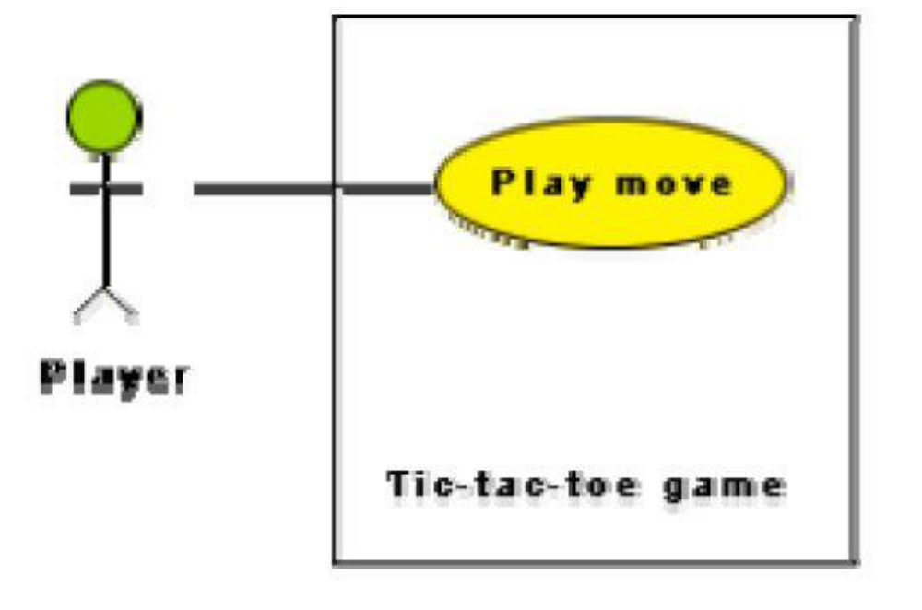

Fig. 4.5: Use case model for tic-tac-toe game

Text Description
Each ellipse on the use case diagram should be accompanied by a text description. The text description should define the details of the interaction between the user and the computer and other aspects of the use case. It should include all the behavior associated with the use case in terms of the mainline sequence, different variations to the normal behavior, the system responses associated with the use case, the exceptional conditions that may occur in the behavior, etc. The behavior description is often written in a conversational style describing the interactions between the actor and the system. The text description may be informal, but some structuring is recommended. The following are some of the information which may be included in a use case text description in addition to the mainline sequence, and the alternative scenarios.
Contact persons: This section lists the personnel of the client organization with whom the use case was discussed, date and time of the meeting, etc.
Actors: In addition to identifying the actors, some information about actors using this use case which may help the implementation of the use case may be recorded.
Pre-condition: The preconditions would describe the state of the system before the use case execution starts.
Post-condition: This captures the state of the system after the use case has successfully completed.
Non-functional requirements: This could contain the important constraints for the design and implementation, such as platform and environment conditions, qualitative statements, response time requirements, etc.
Exceptions, error situations: This contains only the domain-related errors such as lack of user’s access rights, invalid entry in the input fields, etc. Obviously, errors that are not domain related, such as software errors, need not be discussed here.
Sample dialogs: These serve as examples illustrating the use case.
Specific user interface requirements: These contain specific requirements for the user interface of the use case. For example, it may contain forms to be used, screen shots, interaction style, etc.
Document references: This part contains references to specific domain-related documents which may be useful to understand the system operation
Example 2:
A supermarket needs to develop the following software to encourage regular customers. For this, the customer needs to supply his/her residence address, telephone number, and the driving license number. Each customer who registers for this scheme is assigned a unique customer number (CN) by the computer. A customer can present his CN to the checkout staff when he makes any purchase. In this case, the value of his purchase is credited against his CN. At the end of
each year, the supermarket intends to award surprise gifts to 10 customers who make the highest total purchase over the year. Also, it intends to award a 22 caret gold coin to every customer whose purchase exceeded Rs.10,000. The entries against the CN are the reset on the day of every year after the prize winners’ lists are generated.
The use case model for the Supermarket Prize Scheme is shown in Fig. 4.6. As discussed earlier, the use cases correspond to the high-level functional requirements. From the problem description, we can identify three use cases: “register-customer”, “register-sales”, and “select-winners”. As a sample, the text description for the use case “register-customer” is shown.

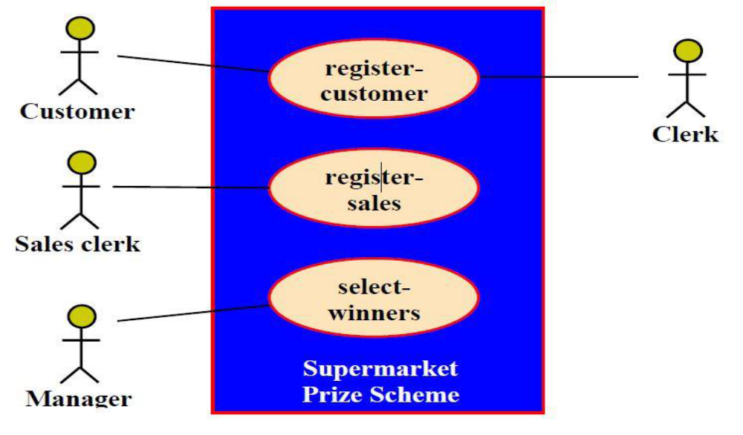

Fig. 4.6 Use case model for Supermarket Prize Scheme

Utility of use case diagrams
From use case diagram, it is obvious that the utility of the use cases are represented by ellipses. They along with the accompanying text description serve as a type of requirements specification of the system and form the core model to which all other models must conform. But, what about the actors (stick person icons)? One possible use of identifying the different types of users (actors) is in identifying and implementing a security mechanism through a login system, so that each actor can involve only those functionalities to which he is entitled to. Another possible use is in preparing the documentation (e.g. users’ manual) targeted at each category of user. Further, actors help in identifying the use cases and understanding the exact functioning of the system.
Factoring of use cases
It is often desirable to factor use cases into component use cases. Actually, factoring of use cases are required under two situations. First, complex use cases need to be factored into simpler use cases. This would not only make the behavior associated with the use case much more comprehensible, but also make the corresponding interaction diagrams more tractable. Without decomposition, the interaction diagrams for complex use cases may become too large to be accommodated on a single sized (A4) paper. Secondly, use cases need to be factored whenever there is common behavior across different use cases. Factoring would make it possible to define such behavior only once and reuse it whenever required. It is desirable to factor out common usage such as error handling from a set of use cases. This makes analysis of the class design much simpler and elegant. However, a word of caution here. Factoring of use cases should not be done except for achieving the above two objectives. From the design point of view, it is not advantageous to break up a use case into many smaller parts just for the sake of it.

Module 5

5. DEBUGGING, INTEGRATION AND SYSTEM TESTING
Need for Debugging
Once errors are identified in a program code, it is necessary to first identify the precise program statements responsible for the errors and then to fix them. Identifying errors in a program code and then fix them up are known as debugging.
Debugging Approaches
The following are some of the approaches popularly adopted by programmers for debugging.

Brute Force Method:
This is the most common method of debugging but is the least efficient method. In this approach, the program is loaded with print statements to print the intermediate values with the hope that some of the printed values will help to identify the statement in error. This approach becomes more systematic with the use of a symbolic debugger (also called a source code debugger), because values of different variables can be easily checked and break points and watch points can be easily set to test the values of variables effortlessly.

Backtracking:
This is also a fairly common approach. In this approach, beginning from the statement at which an error symptom has been observed, the source code is traced backwards until the error is discovered. Unfortunately, as the number of source lines to be traced back increases, the number of potential backward paths increases and may become unmanageably large thus limiting the use of this approach.

Cause Elimination Method:
In this approach, a list of causes which could possibly have contributed to the error symptom is developed and tests are conducted to eliminate each. A related technique of identification of the error from the error symptom is the software fault tree analysis.

Program Slicing:
This technique is similar to back tracking. Here the search space is reduced by defining slices. A slice of a program for a particular variable at a particular statement is the set of source lines preceding this statement that can influence the value of that variable.

Guidelines for Debugging Software
Debugging is often carried out by programmers based on their ingenuity. The following are some general guidelines for effective debugging:
• Many times debugging requires a thorough understanding of the program design. Trying to debug based on a partial understanding of the system design and implementation may require an inordinate amount of effort to be put into debugging even simple problems.
• Debugging may sometimes even require full redesign of the system. In such cases, a common mistake that novice programmers often make is attempting not to fix the error but its symptoms.
• One must be beware of the possibility that an error correction may introduce new errors. Therefore after every round of error-fixing, regression testing must be carried out.
Program Analysis Tools
A program analysis tool means an automated tool that takes the source code or the executable code of a program as input and produces reports regarding several important characteristics of the program, such as its size, complexity, adequacy of commenting, adherence to programming standards, etc. We can classify these into two broad categories of program analysis tools:
• Static Analysis tools
• Dynamic Analysis tools
• Static program analysis tools

Static Analysis Tool is also a program analysis tool. It assesses and computes various characteristics of a software product without executing it. Typically, static analysis tools analyze some structural representation of a program to arrive at certain analytical conclusions, e.g. that some structural properties hold. The structural properties that are usually analyzed are:
• Whether the coding standards have been adhered to?
• Certain programming errors such as uninitialized variables and mismatch between actual and formal parameters, variables that are declared but never used are also checked.

Code walk through and code inspections might be considered as static analysis methods. But, the term static program analysis is used to denote automated analysis tools. So, a compiler can be considered to be a static program analysis tool.
Dynamic program analysis tools - Dynamic program analysis techniques require the program to be executed and its actual behavior recorded. A dynamic analyzer usually instruments the code (i.e. adds additional statements in the source code to collect program execution traces). The instrumented code when executed allows us to record the behavior of the software for different test cases. After the software has been tested with its full test suite and its behavior recorded, the dynamic analysis tool caries out a post execution analysis and produces reports which describe the structural coverage that has been achieved by the complete test suite for the program. For example, the post execution dynamic analysis report might provide data on extent statement, branch and path coverage achieved.
Normally the dynamic analysis results are reported in the form of a histogram or a pie chart to describe the structural coverage achieved for different modules of the program. The output of a dynamic analysis tool can be stored and printed easily and provides evidence that thorough testing has been done. The dynamic analysis results the extent of testing performed in white-box mode. If the testing coverage is not satisfactory more test cases can be designed and added to the test suite. Further, dynamic analysis results can help to eliminate redundant test cases from the test suite.

SOFTWARE TESTING

This section explains the concept of software testing, methods, types, advantages and disadvantages. Software testing is the process of evaluating and verifying that a software application or system works as intended. Or software testing is the process of evaluating and verifying that a software product or application does what it is supposed to do. One of the goals of software testing is to identify defects or bugs early in the development cycle, improve software quality and ensure the product meets user requirements and expectations. The benefits of broadly testing software products are: to prevent bugs, reduce development costs so that the software products can achieve improved performance.

There are various methods and types of software testing. Each serves a specific purpose in the software development lifecycle.

METHODS OF SOFTWARE TESTING

a. Manual Testing

Manual testing involves human testers executing test cases without the assistance of automation tools. The tester interacts with the application, checks for issues, and validates whether the system behaves as expected.
- Activities in manual testing of software:
  - Test Planning: Testers create test cases and scenarios based on requirements and functional specifications.
  - Test Execution: Testers execute test cases manually and record the results.
  - Defect Reporting: Any defects discovered during the testing phase are documented and reported for fixing.

- Advantages:
  - Human Intuition: Testers can explore the application and use their intuition to detect unexpected issues that automation might miss.
  - Flexibility: Manual testing is useful for exploratory, usability, and ad-hoc testing, where test cases may not be predefined.
  - Cost-Effective for Small Projects: For small applications or limited projects, manual testing can be faster and more economical.
- Disadvantages:
  - Time-Consuming: Testing is slow and repetitive, especially for large and complex applications.
  - Prone to Errors: Manual testing can lead to human error due to oversight or fatigue.
  - Not Scalable: Manual testing is difficult to scale for large, ongoing projects or frequent releases.

b. Automated Testing

Automated testing involves using testing tools or scripts to automatically execute tests on the application, compare the actual outcome to the expected result, and report any discrepancies.
- Activities in automated software testing:
  - Test Script Development: Writing automation scripts that define the test scenarios.
  - Test Execution: Automation tools execute the tests on the software application.
  - Reporting: The system automatically generates test results and logs.

- Advantages:
  - Speed: Automated tests can execute much faster than manual testing, especially for regression tests.
  - Reusability: Once written, test scripts can be reused for multiple test cycles or different versions of the software.
  - Consistency: Automated tests provide consistent results, eliminating human error.
  - Better for Regression Testing: Automated tests are perfect for repetitive tests and regression testing after code changes.
- Disadvantages:
  - Initial Cost and Effort: Developing automated tests can be time-consuming and costly upfront.
  - Maintenance: Automated test scripts need to be updated when the application changes, which can increase maintenance overhead.
  - Not Ideal for All Test Types: Some tests, such as usability or exploratory testing, are difficult to automate.

INTEGRATION TESTING
Integration testing focuses on testing the interactions between multiple components, modules or services of an application to ensure they work together as expected. The primary objective of integration testing is to test the module interfaces so that there will be no errors in the parameter passing, when one module invokes another module. This type of testing occurs after unit testing and before system testing. Below are the key advantages and disadvantages of integration testing.
During integration testing, different modules of a system are integrated in a planned manner using an integration plan. The integration plan specifies the steps and the order in which modules are combined to realize the full system. After each integration step, the partially integrated system is tested. An important factor that guides the integration plan is the module dependency graph. The structure chart (or module dependency graph) denotes the order in which different modules call each other. By examining the structure chart the integration plan can be developed.

Advantages of Integration Testing
- It helps to detect interface issues early: Integration testing helps identify issues in the interactions between integrated modules or components. By testing the interface between modules, it ensures that data and control flow between them is correct, preventing bugs that could arise when modules are combined later.
- It improves system reliability: By verifying that different components interact smoothly, integration testing improves the overall reliability of the system. It reduces the risk of issues in the later stages of development, making the final product more robust.
- It simplifies bug identification: Since integration testing tests the communication between modules, it can help pinpoint problems related to how modules interact. Identifying issues at this stage can be easier than waiting for system testing, where issues might involve multiple interconnected components.
- It validates functional interactions: It ensures that when different modules are integrated, they function as expected. For instance, it checks if data passed from one module is correctly received and processed by the next, ensuring that each component functions correctly as part of a larger whole.
- It helps to ensure early detection of regression bugs: Integration testing allows for the early detection of regressions caused by changes to a module. By testing the integration points frequently, it is easier to spot problems introduced during the development process and fix them before they affect the entire system.
- It improves code quality: Since integration testing is usually done with the aim of making the modules work together, it often leads to cleaner, more modular code. Developers may need to refactor or optimize code to ensure proper integration, resulting in higher code quality.

Disadvantages of Integration Testing
- It can be time-consuming: Integration testing can take significant time, especially in complex systems with many interacting components. Setting up the necessary environments and running multiple test cases to ensure every integration point works can lead to increased testing time.
- It has complex test scenarios: Integration tests can become difficult to manage, especially when multiple modules are involved. The complexity of interactions and dependencies can make it challenging to create and maintain effective test scenarios, leading to longer test creation times.
- It is difficult to isolate bugs (or problems): If an issue arises during integration testing, it might be challenging to isolate the root cause of the problem because it involves the interaction of multiple components. Debugging these issues can be harder compared to unit testing, where problems are more contained within individual components.
- It requires a fully developed environment: Integration testing typically requires that most of the system is already developed, as it focuses on testing interactions between completed modules. For systems under development, this means that integration testing might be delayed until later in the development process, making it harder to spot issues early.
- It relies on pre-existing modules: If one or more modules are not fully developed or are not functioning as expected, it can impact the effectiveness of integration testing. Missing or incomplete modules may lead to gaps in test coverage or test failures, which may not represent the actual behavior when the system is fully integrated.
- It has limited coverage of individual module performance: While integration testing ensures that different modules work together, it does not guarantee that each module behaves correctly on its own. For example, a module might work fine in isolation (as verified by unit testing) but may behave incorrectly when integrated with others due to assumptions or side effects. This is why integration testing is typically preceded by thorough unit testing.

Integration test approaches
There are four types of integration testing approaches. Any one (or a mixture) of the following approaches can be used to develop the integration test plan. Those approaches are the following:
• Big bang approach
• Bottom- up approach
• Top-down approach
• Mixed-approach

Big-Bang Integration Testing
It is the simplest integration testing approach, where all the modules making up a system are integrated in a single step. In simple words, all the modules of the system are simply put together and tested. However, this technique is practicable only for very small systems. The main problem with this approach is that once an error is found during the integration testing, it is very difficult to localize the error as the error may potentially belong to any of the modules being integrated. Therefore, debugging errors reported during big bang integration testing are very expensive to fix.

Bottom-Up Integration Testing: Advantages and Disadvantages
In bottom-up integration testing, the individual components or modules (subsystems) of a software product are tested in a bottom-up manner, starting from the lowest level of the system (i.e., the most fundamental components) and progressively integrating higher-level modules (the full system). The testing begins with the leaf modules or lower-level components, and as each module is verified, it is combined with higher-level components in the system, until the entire system is integrated and tested. A subsystem might consist of many modules which communicate among each other through well-defined interfaces. The primary purpose of testing each subsystem is to test the interfaces among various modules making up the subsystem. Both control and data interfaces are tested. The test cases must be carefully chosen to exercise the interfaces in all possible manners. Large software systems normally require several levels of subsystem testing; lower-level subsystems are successively combined to form higher-level subsystems.
Advantages of Bottom-Up Integration Testing
- It facilitates early detection of low-level issues: Bottom-up testing helps detect issues early in the development process, particularly those related to individual components and their interfaces. By testing low-level modules first, developers can identify problems at a granular level, which might be difficult to detect once more components are integrated.
- It simplifies the debugging of software defects: Since testing starts at the lowest level, any problems identified are likely isolated within the smaller components. This makes it easier to locate and fix defects because the root cause of any failure will be confined to a specific module rather than an interaction between multiple modules.
- It is useful for testing complex components first: Some components of the system may be more complex or critical than others. Bottom-up testing allows these modules to be tested first in isolation, ensuring they function correctly before they are integrated with the rest of the system.
- It reduces dependency on upper-level modules: Since lower-level modules are tested first, there is no need to wait for higher-level modules or the full system to be completed. This allows development and testing of different layers of the application to proceed concurrently, improving productivity.
- It facilitates incremental development of software: Bottom-up testing allows an incremental approach to system integration, where smaller parts of the system can be tested and refined progressively. This enables developers to address issues as they arise rather than waiting until the entire system is ready for testing.

Disadvantages of Bottom-Up Integration Testing
- It delays the testing of higher-level components of software products: One of the main drawbacks is that the higher-level components, which generally involve more complex and critical business logic, are not tested until later in the process. This can result in a delay in identifying issues in the more integral parts of the system.
- It requires stubs for higher-level modules: Since the testing begins with lower-level modules, the higher-level modules, which are not yet integrated, need to be simulated. These simulated components, known as stubs, are used to mimic the behavior of the untested modules. Creating and maintaining these stubs can be time-consuming and error-prone, especially in larger systems.
- It has limited view of system functionality: Testing in isolation may not reveal how well the system as whole functions when all components are integrated. Since the focus is on individual modules, there is a risk that the interactions between components may not be adequately tested until the later stages.
- It can cause complex test management: Managing test cases and environments in bottom-up integration testing can become complex. As the system grows and more modules are integrated, test cases and their dependencies may become difficult to handle, leading to difficulties in ensuring thorough test coverage.
- It is not ideal for software products with strong top-down dependencies:
Some systems may have a strong dependency on higher-level modules. For such systems, bottom-up testing may not be ideal, as important functionalities might not be available until the higher-level modules are integrated. In such cases, top-down integration testing may be more appropriate.
- It delays discovery of system-wide issues (or defects): In bottom-up testing, the overall system is tested only once higher-level modules are integrated. Therefore, system-wide issues related to the integration of modules at the top level might not be discovered until later in the testing cycle, which could delay the overall project timeline.

Top-Down Integration Testing: Advantages and Disadvantages
Top-Down Integration Testing is a type of integration testing where testing starts from the top level of the system's architecture (the highest-level modules or components) and works down toward the lower-level modules. The top-level modules, which contain the core system functionality, are tested first while the lower-level modules are integrated progressively. The integration testing can start with the main routine and one or two subordinate routines in the system. After the top-level ‘skeleton’ has been tested, the immediately subroutines of the ‘skeleton’ are combined with it and tested. Top-down integration testing approach requires the use of program stubs to simulate the effect of lower-level routines that are called by the routines under test.

Advantages of Top-Down Integration Testing
- It facilitates early validation of high-level functionality: Top-down testing focuses on validating the core, high-level functionality of the system early in the process. This ensures that the most critical parts of the application (those closer to the end-user experience) work as expected, even before lower-level details are integrated.
- It facilitates faster detection of major issues (defects): By starting at the top, you can quickly uncover system-wide issues that could affect the functionality of the application. For example, defects in the communication between high-level modules are more likely to be detected early in the process.
- It provides early user perspective on the software product: Since the higher-level modules typically align with the user interface (UI) and main functionality, testing these modules first can provide early insights into the user experience and business logic of the application. This is particularly valuable when the user-facing aspects are a priority.
- It enables simpler stub creation: In top-down testing, you use stubs for the lower-level modules, which are relatively easy to create. These stubs only need to simulate the interfaces of the lower-level modules without having to replicate their full functionality. This makes it easier to proceed with testing without waiting for the full system to be developed.
- It is easier to validate system flow: Since testing starts from the top level, the flow of control between modules can be validated right away. It ensures that high-level interactions and business logic are working as expected before you deal with the detailed implementation of lower-level components.
- It supports incremental development of software product: Top-down testing fits well with incremental development, where the system is built and tested in parts. You can begin testing the high-level modules and progressively integrate more components as they are developed, ensuring that each level works as expected before moving on.

Disadvantages of Top-Down Integration Testing
- It requires stubs for lower-level modules: Since lower-level modules are integrated last, stubs must be used to simulate their behavior. While stubs are useful, they do not represent the full functionality of the real modules. This can make the testing process less accurate, as the behavior of the system may differ when real modules are integrated later.
- It delays discovery of low-level issues (defects): Low-level modules are tested later in the process, so any issues related to them may not be discovered until the later stages of integration testing. This can delay the identification of critical issues in lower-level functionality, making it harder to pinpoint the source of defects.
- It can lead to complex integration of lower-level modules: As more and more lower-level modules are integrated, the testing process becomes increasingly complex. The interactions between these modules and the high-level modules might lead to unforeseen issues, which could require additional time to troubleshoot.
- It is not ideal for large systems: For large systems with numerous lower-level modules, top-down testing can be inefficient. The testing process might be slow because it involves waiting until the higher-level modules are fully functional before integrating the next layers. In such cases, other integration testing approaches (like bottom-up testing or a hybrid approach) might be more suitable.
- It has limited coverage of lower-level functionality of the software products: Since the focus is on the top-level modules, there is a risk that the lower-level modules’ specific behaviors, edge cases, and interactions might not be thoroughly tested until much later in the process. This can result in missed bugs or integration issues in the lower levels.
- It cannot adequately test the interactions between lower-level components of software products: Since testing begins at the top level, there may be insufficient validation of the interactions between lower-level modules until later. The communication between lower-level components may not be fully tested until later stages, which could affect the overall system integration.

Essentially, both bottom-Up and Top-down Integration Testing methods are useful approaches when testing complex (high-level) and low-level modules. However, they come with inherent challenges. It is important to choose the right approach based on the system's structure, development timeline, and the nature of the components being tested. In many cases, a hybrid approach combining both bottom-up and top-down testing may be adopted to maximize efficiency and thoroughness in the testing process.

Mixed Integration Testing, Advantages and Disadvantages
Mixed Integration Testing (also known as sandwiched or Hybrid Integration Testing) is a combination of both Top-Down Integration Testing and Bottom-Up Integration Testing approaches. This technique allows testers to leverage the strengths of both strategies, testing different components and interactions at various levels of the system, often based on the project's needs and priorities. The mixed approach overcomes this shortcoming of the top-down or bottom-up approaches. It enables that high-level and low-level modules are tested simultaneously, leading to early detection of critical system issues and more thorough testing coverage.

Advantages of Mixed Integration Testing
- Balanced Testing Coverage: By combining both top-down and bottom-up strategies, mixed integration testing ensures that both high-level and low-level components are tested early. This balance allows the system to be tested holistically, identifying issues across all layers of the system.
- Faster Detection of Critical System Issues: The top-down approach quickly detects system-wide issues related to the high-level functionality and user interactions. Meanwhile, the bottom-up approach focuses on verifying the behavior of lower-level components and their interactions. Combining both strategies speeds up the detection of critical issues at different layers of the system.
- Early Testing of Core Functionalities: High-level modules, which usually contain core business logic and user-facing features, can be tested early in the process. This helps validate that the key functionalities of the application work correctly before adding more complexity with lower-level modules.
- Improved Fault Isolation: By testing modules from both ends (high-level and low-level), any faults or defects can be isolated more efficiently. If an issue arises, it’s easier to determine whether the problem lies in the interaction between higher-level modules (top-down) or in the lower-level modules (bottom-up).
- Flexibility in Testing: A mixed approach offers flexibility in adapting the testing strategy based on the system’s structure, the complexity of modules, and development priorities. If certain modules are more critical, they can be tested early (top-down), while less critical or complex components can be verified in later stages (bottom-up).
- Early Identification of Integration Issues: Combining both strategies enables a more comprehensive check of the interactions between modules. As the system is incrementally integrated from both ends, potential integration issues that span multiple modules can be identified early on, even in a system with complex dependencies.
- Suitability for Large and Complex Systems: In large systems with multiple layers or components, a mixed approach allows testing to occur at different levels concurrently. This is beneficial for systems that are too large or complex to be effectively tested with a single strategy, as it divides the workload into manageable sections.

Disadvantages of Mixed Integration Testing
- Increased Complexity: The mixed approach can increase the complexity of test management, as both top-down and bottom-up testing strategies must be coordinated. Testers must ensure that both approaches are applied correctly, and test cases need to be managed carefully across different levels of the system.
- More Effort in Setting Up Stubs and Drivers: Stubs (for bottom-up testing) and drivers (for top-down testing) need to be developed and maintained, which can be time-consuming and error-prone. Since both top-down and bottom-up strategies are used, testers may need to create more test scaffolding than with a single approach.
- Risk of Redundancy: There is a possibility of redundancy in testing, as some functionalities may be tested twice (once from the top-down and once from the bottom-up), leading to unnecessary duplication of effort and potentially increasing the time required for testing.
- Inconsistent Test Coverage: While the goal is balanced testing, in practice, it can be difficult to ensure that all components receive the appropriate level of attention. Some components might be tested more thoroughly than others, or some aspects may be overlooked, especially if the integration of multiple strategies are not properly managed.
- More Resources Required: Implementing a mixed approach typically requires more resources in terms of time, manpower, and tools. Testers need to be skilled in both top-down and bottom-up approaches, and there may be a need for extra time and effort to ensure that both strategies are applied effectively.
- Complicated Debugging: Since the system is tested at multiple levels concurrently, debugging can become more complicated if an issue is found. Determining whether the problem is due to the integration at a higher level or a lower-level interaction can be challenging, particularly when multiple testing approaches are in use.
- Higher Initial Setup Cost: The preparation phase, which includes creating both stubs and drivers, can incur additional costs. This preparation time might delay the start of the actual testing process, which can affect the overall project timeline, especially in the early stages of development.

Essentially, mixed integration testing approach also introduces additional complexity, requires more resources, and can lead to redundant or inconsistent testing if not managed carefully. For complex and large systems, where testing the entire system comprehensively is necessary, mixed integration testing can be a powerful strategy. Therefore, it is crucial to carefully plan and balance the use of both top-down and bottom-up testing to avoid the downsides of redundancy, complexity and resource overhead.

Approaches to perform integration testing

Phased testing versus Incremental testing approaches
The different integration testing strategies are either phased or incremental. A comparison of these two strategies is as follows:
o In incremental integration testing, only one new module is added to the partial system each time.
o In phased integration, a group of related modules are added to the partial system each time.

Phased integration requires less number of integration steps compared to the incremental integration approach. However, when failures are detected, it is easier to debug the system in the incremental testing approach since it is known that the error is caused by addition of a single module. In fact, big bang testing is a degenerate case of the phased integration testing approach.

System testing
System tests are designed to validate a fully developed system to assure that it meets its requirements. There are essentially three main kinds of system testing:
• Alpha Testing(α). Alpha testing refers to the system testing carried out by the test team within the developing organization.
• Beta testing (β). Beta testing is the system testing performed by a select group of friendly customers.
• Acceptance Testing. Acceptance testing is the system testing performed by the customers to determine whether they should accept the delivery of the software system.

Black Box Testing
Black box testing focuses on testing the software without knowledge of its internal structure. The tester only knows the input and expected output, and the system is treated as a "black box."
- Examples:
  - Functional Testing: Verifies that the system produces correct outputs based on given inputs.
  - Acceptance Testing: Focuses on validating the system against user requirements without looking at the code.
- Advantages:
  - Tester has no Knowledge of code required: Testers do not need to understand the code, making it suitable for testers with no programming experience.
  - User-Centric: Focuses on what the system is supposed to do from the user’s perspective, ensuring it meets functional requirements.
- Disadvantages:
  - It has limited test coverage: Black box testing may miss testing areas such as performance or error-handling logic inside the code.
  - It is difficult to identify root causes of defects: Since the internal logic is not considered, debugging and identifying the cause of failures can be challenging.
d. White Box Testing
White box testing, also known as structural testing, involves testing the internal workings of an application. The tester has access to the source code and tests the system’s internal logic, structure, and algorithms.
- Examples:
  - Unit Testing: Verifies the correctness of individual components or functions in the code.
  - Code Coverage Testing: Ensures that all parts of the code are executed and tested.
  - Path Testing: Verifies that all possible paths through the code are tested.
- Advantages:
  - It enables thorough testing of software products: Ensures the code is tested in detail, including logic, paths, and loops.
  - It is effective for assessing the security and performance of software products: Helps detect vulnerabilities and performance issues within the internal code structure.
- Disadvantages:
  - It requires sound programming knowledge: Testers need to have knowledge of the programming language and the system's internal logic.
  - It is complex to perform: White box testing can be complex and time-consuming, particularly for large systems.

In each of the above types of tests, various kinds of test cases are designed by referring to the SRS document. Broadly, these tests can be classified into functionality and performance tests. The functionality test tests the functionality of the software to check whether it satisfies the functional requirements as documented in the SRS document. The performance test tests the conformance of the system with the nonfunctional requirements of the system.

Performance Testing
Performance testing is carried out to check whether the system needs the non-functional requirements identified in the SRS document. There are several types of performance testing. Among of them nine types are discussed below. The types of performance testing to be carried out on a system depend on the different non-functional requirements of the system documented in the SRS document. All performance tests can be considered as black-box tests.
• Stress testing
• Volume testing
• Configuration testing
• Compatibility testing
• Regression testing
• Recovery testing
• Maintenance testing
• Documentation testing
• Usability testing

Stress Testing
Stress testing is also known as endurance testing. Stress testing evaluates system performance when it is stressed for short periods of time. Stress Testing involves testing a system by subjecting it to extreme conditions (like high loads or resource depletion) to evaluate how it behaves under stress and how it recovers. Stress tests are black box tests which are designed to impose a range of abnormal and even illegal input conditions so as to stress the capabilities of the software. Input data volume, input data rate, processing time, utilization of memory, etc. are tested beyond the designed capacity. For example, suppose an operating system is supposed to support 28 multi programmed jobs, the system is stressed by attempting to run 28 or more jobs simultaneously. A real-time system might be tested to determine the effect of simultaneous arrival of several high-priority interrupts.
Stress testing is especially important for systems that usually operate below the maximum capacity but are severely stressed at some peak demand hours. For example, if the non-functional requirement specification states that the response time should not be more than 20 secs per transaction when 60 concurrent users are working, then during the stress testing the response time is checked with 60 users working simultaneously.

Advantages of stress testing:
- Identifies system limits: Helps determine the maximum load the system can handle before failure.
- Reveals system weaknesses: Uncovers bottlenecks, failures, and vulnerabilities that may not appear under normal conditions.
- Improves system robustness: Helps ensure that the system can recover gracefully from crashes or failures.
Disadvantages of stress testing:
- Difficult to replicate real-world conditions: Stress scenarios might not always mirror real-world conditions, making results potentially less practical.
- Time-consuming: Stress testing may require substantial system configuration and testing time, especially for large or complex systems.
- Can cause data loss or corruption: Subjecting the system to extreme stress might result in data corruption or loss if the system isn't designed to handle such conditions.

Volume Testing
Volume Testing involves testing the system with a large volume of data to evaluate its behavior when handling vast amounts of information. Volume testing is especially important for assessing whether the data structures (arrays, queues, stacks, etc.) have been designed to manage extraordinary situations. For example, a compiler might be tested to check whether the symbol table overflows when a very large program is compiled.

Advantages of volume testing:
- Identifies performance bottlenecks: Helps assess the system’s ability to handle large volumes of data without performance degradation.
- Assesses data integrity: Ensures that the system maintains data accuracy and consistency when processing large datasets.
- Helps optimize the system: Provides insights into how to improve scalability and optimize system performance.

Disadvantages of volume testing:
- Resource-intensive: Requires significant hardware and infrastructure to simulate large volumes of data, which can be costly and time-consuming.
- Not always representative of real-world conditions: It may be difficult to generate data that exactly mimics real-world scenarios, especially in non-standard applications.
- Potential for errors: Large datasets might cause issues with memory management, leading to potential system crashes or data corruption.

Configuration Testing –

Configuration Testing involves testing the software in various hardware, software, network, and environment configurations to ensure compatibility and performance.
It is used to analyze system behavior in various hardware and software configurations specified in the requirements. Sometimes software products are built in variable configurations for different users. For instance, we might define a minimal system to serve a single user, and other extension configurations to serve additional users. The system is configured in each of the required configurations and it is checked if the system behaves correctly in all required configurations.
Advantages of configuration testing:
- Ensures cross-environment compatibility: Ensures that the software works across a variety of different system configurations, operating systems, and hardware setups.
- Improves reliability: Helps in identifying configuration-related issues that could affect the software’s stability and reliability.
- Broadens market reach: Validates that the software can be deployed across various configurations, making it more versatile and usable for different users.
Disadvantages of configuration testing:
- Time-consuming: It requires testing on multiple hardware and software configurations, which can be resource-intensive.
- Difficult to cover all combinations: It’s challenging to test every possible configuration, especially in large systems, leading to the possibility of untested configurations.
- Expensive: Involves setting up multiple environments and configurations, which can increase testing costs and resources.

Compatibility Testing
Compatibility Testing ensures that the software functions (or interfaces with other types of systems) as expected across different operating systems, browsers, devices, and network environments. Compatibility aims to check whether the interface is compatible and functions are perform as required. For instance, if the system needs to communicate with a large database system to retrieve information, compatibility testing is required to test the software is well-suited to required components that will ensure high speed and accuracy of data retrieval.
Advantages of compatibility testing:
- Ensures broad usability: Guarantees that the software is compatible with multiple platforms, devices, and environments, enhancing its usability and marketability.
- Improves user experience: Ensures a consistent user experience regardless of the device or platform used.
- Identifies environmental dependencies: Helps identify any environmental factors that may cause the software to malfunction.
Disadvantages of compatibility testing:
- Time-consuming: Involves testing across multiple platforms, operating systems, and configurations, which can be resource and time-intensive.
- Expensive to perform: Requires resources to maintain diverse environments for testing purposes.
- Risk of incomplete coverage: With so many combinations, it may not be feasible to test all possible scenarios, leading to potential gaps in coverage.

Regression Testing
Regression Testing ensures that new code changes or additions do not negatively affect the existing functionality of the software. Regression testing is required especially when the system being tested is an upgrade of an already existing system with the intention to fix some bugs or enhance functionality, performance, etc. Regression testing is the practice of running an old test suite after each change to the system or after each bug fix to ensure that no new bug has been introduced due to the change or the bug fix. That is regression testing ensures that new code changes have not negatively impacted existing features or functionality. It involves rerunning previous test cases after new changes are made to the system.

Advantages of Regression testing:
- Ensures stability: Helps ensure that existing features continue to work as expected after code changes.
- Detects unintended side effects: Identifies regressions or unintended side effects that may arise from updates, patches, or new features.
- Helps in continuous integration: Facilitates the continuous development process by validating new changes against existing functionality.
Disadvantages of Regression testing:
- Time-consuming: As the software grows, the number of test cases increases, which can make regression testing lengthy and complex.
- Potential for over-testing: A large number of test cases can lead to redundant or unnecessary tests, which can be inefficient.
- Requires ongoing updates: Test cases must be constantly updated as the software evolves, requiring continuous effort.

Recovery Testing
Recovery Testing evaluates the software’s ability to recover from failures, such as crashes, hardware failures and power outages. Recovery testing tests the response of the system to the presence of faults, or loss of power, devices, services, data, etc. The system is subjected to the loss of the mentioned resources (as applicable and discussed in the SRS document) and it is checked if the system recovers satisfactorily. For example, the printer can be disconnected to check if the system hangs. Or, the power may be shut down to check the extent of data loss and corruption.
Advantages of recovery testing:
- Ensures system resilience: Helps ensure that the system can recover gracefully from various types of failures, improving its robustness.
- Improves disaster recovery planning: Tests backup and recovery processes, ensuring that the system can return to normal operation quickly after a failure.
- Enhances user confidence: A well-recovered system assures users that the application can handle unexpected failures.
Disadvantages of recovery testing:
- Complex setup: Setting up the necessary failure conditions can be difficult, especially in a controlled test environment.
- Time-consuming: Testing recovery scenarios might require repeated execution and monitoring, which can be resource-intensive.
- Hard to simulate all failure scenarios: It may be impossible to simulate every possible failure mode, leading to gaps in recovery testing.

Exploratory Testing
Exploratory testing involves testers actively exploring the software without predefined test cases to discover issues that might not have been anticipated in the requirements.

Advantages of exploratory Testing:
- Creative Testing: Allows testers to use their intuition and creativity to identify unanticipated issues.
- Quick Feedback: Provides fast, actionable feedback on the system’s behavior.

Disadvantages of exploratory Testing:
- Unstructured: Since it’s less structured, exploratory testing may miss certain functionality or areas of the application.
- Limited Coverage: It may not be as comprehensive as formal testing methods with detailed test plans.

Maintenance Testing
Maintenance Testing involves testing the software after it has been deployed to ensure that any changes, updates or patches do not adversely affect the software. This testing addresses the diagnostic programs, and other procedures that are required to be developed to help maintenance of the system. It is verified that the artifacts exist and they perform properly.
Advantages of maintenance testing:
- Ensures continued software quality: Helps maintain the software’s reliability and functionality over time, even after changes or updates.
- Validates bug fixes and updates: Ensures that previously reported bugs are fixed and that the software continues to meet user requirements.
- Improves long-term system stability: Helps identify and correct issues that may arise during the software’s operational life.
Disadvantages of maintenance testing:
- Costly and resource-intensive: Requires ongoing investment of resources and time for maintenance testing over the product's lifecycle.
- May lead to regression: New fixes or updates may unintentionally introduce regressions in other parts of the system.
- Time-consuming: Given the continuous nature of software updates, maintenance testing can become increasingly complex and time-consuming.

Documentation Testing
Documentation Testing involves testing the software documentation (user manuals, help files, etc.) to ensure it is accurate, comprehensive, and useful. Documentation Testing ensures that user manual, maintenance manuals and technical manuals exist and are consistent. If the requirements specify the types of audience for which a specific manual should be designed, then the manual is checked for compliance.
Advantages of documentation testing:
- Ensures clear communication: Ensures that users and administrators can understand and effectively use the software.
- Improves user experience: Well-documented software can improve the user experience by providing clear instructions and troubleshooting help.
- Supports training and onboarding: Quality documentation supports user onboarding and training processes. User onboarding is the process of helping new users get familiar with a product or system, ensuring they know how to use it effectively from the start. In essence, well-organized, clear and detailed documentation plays a key role in helping new users or employees get started with a software product. It also helps to train them effectively on how to use the software product.
Disadvantages of documentation testing:
- Time-consuming: Reviewing documentation for accuracy and completeness can be a slow and meticulous process.
- Requires expertise: Effective documentation testing requires subject-matter experts to ensure accuracy, which can be challenging to source.
- Easily overlooked: Documentation may not receive the same level of attention as the software itself, leading to discrepancies or incomplete guidance.

Usability Testing
Usability Testing focuses on assessing the ease of use, user satisfaction, and overall user experience of the software. It concerns checking the user interface to see if it meets all user requirements concerning the user interface. During usability testing, the display screens, report formats, and other aspects relating to the user interface requirements are tested.
Advantages of usability testing:
Improves user experience: Identifies user interface (UI) and user experience (UX) issues, allowing for design improvements.
Enhances customer satisfaction: A user-friendly application leads to higher customer satisfaction and adoption.
Provides valuable feedback: Direct user feedback from usability testing helps prioritize changes that will make the software more intuitive.

Disadvantages of usability testing:

Requires real users: Usability testing needs real users, which can be costly and logistically challenging to organize.
Subjective results: Feedback from users can be subjective and may not always reflect the needs of all users.
Time-consuming: It often takes multiple rounds of testing and iteration to fine-tune the software’s usability.

Module 6

6. SOFTWARE MAINTENANCE
Necessity of Software Maintenance
Software maintenance is becoming an important activity of a large number of software organizations. This is no surprise, given the rate of hardware obsolescence, the immortality of a software product per se, and the demand of the user community to see the existing software products run on newer platforms, run in newer environments, and/or with enhanced features. When the hardware platform is changed, and a software product performs some low-level functions, maintenance is necessary. Also, whenever the support environment of a software product changes, the software product requires rework to cope up with the newer interface. For instance, a software product may need to be maintained when the operating system changes. Thus, every software product continues to evolve after its development through maintenance efforts. Therefore, it can be stated that software maintenance is needed to correct errors, enhance features, port the software to new platforms, etc.

Types of software maintenance
There are basically three types of software maintenance. These are:
• Corrective: Corrective maintenance of a software product is necessary to rectify the bugs observed while the system is in use.
• Adaptive: A software product might need maintenance when the customers need the product to run on new platforms, on new operating systems, or when they need the product to interface with new hardware or software.
• Perfective: A software product needs maintenance to support the new features that users want it to support, to change different functionalities of the system according to customer demands, or to enhance the performance of the system.

Problems associated with software maintenance
Software maintenance work typically is much more expensive than what it should be and it takes more time than required. In software organizations, maintenance work is mostly carried out using ad hoc techniques. The primary reason being that software maintenance is one of the most neglected areas of software engineering. Even though software maintenance is fast becoming an important area of work for many companies as the software products of yester years age, still software maintenance is mostly being carried out as fire-fighting operations, rather than through systematic and planned activities.
Software maintenance has a very poor image in industry. Therefore, an organization often cannot employ bright engineers to carry out maintenance work. Even though maintenance suffers from a poor image, the work involved is often more challenging than development work. During maintenance it is necessary to thoroughly understand someone else’s work and then carry out the required modifications and extensions.
Another problem associated with maintenance work is that the majority of software products needing maintenance are legacy products.

Software Reverse Engineering
Software reverse engineering is the process of recovering the design and the requirements specification of a product from an analysis of its code. The purpose of reverse engineering is to facilitate maintenance work by improving the understandability of a system and to produce the necessary documents for a legacy system. Reverse engineering is becoming important, since legacy software products lack proper documentation, and are highly unstructured. Even well-designed products become legacy software as their structure degrades through a series of maintenance efforts.
The first stage of reverse engineering usually focuses on carrying out cosmetic changes to the code to improve its readability, structure, and understandability, without changing of its functionalities. A program can be reformatted using any of the several available pretty printer programs which layout the program neatly. Many legacy software products with complex control structure and unthoughtful variable names are difficult to comprehend. Assigning meaningful variable names is important because meaningful variable names are the most helpful thing in code documentation. All variables, data structures, and functions should be assigned meaningful names wherever possible. Complex nested conditionals in the program can be replaced by simpler conditional statements or whenever appropriate by case statements.
STAKEHOLDERS IN SOFTWARE DEVELOPMENT PROJECT
The following stakeholders play unique and critical roles in ensuring the success of software development project.
1. Strategic Management Team
- Role: The strategic management team is responsible for setting the overall direction and vision of the company. They align the company's goals with the industry landscape and ensure that the software development initiatives are in line with business objectives.
- Key Responsibilities:
  - Defining the company’s long-term strategy and objectives.
  - Ensuring the software development efforts align with the company's business model.
  - Making high-level decisions on budget allocation, resources, and partnerships.
  - Managing risk at the organizational level.
  - Monitoring market trends and adjusting company strategies accordingly.
2. Software Testing Team (Software Testing Engineers)
- Role: The software testing team ensures that the developed software is of high quality, free of bugs and meets the required specifications before it is released to customers.
- Key Responsibilities:
  - Writing and executing test cases to verify the functionality of the software.
  - Identifying and documenting software defects.
  - Performing functional, regression, performance, and security testing.
  - Collaborating with developers to fix bugs and improve product quality.
  - Ensuring the software meets industry standards and user expectations.
  - Automating repetitive testing tasks when possible.
3. Customers (End-users)
- Role: Customers (or end-users) are the primary recipients of the software product. They provide feedback and are the driving force behind the features and functionality of the software.
- Key Responsibilities:
  - Providing feedback on the software’s usability, functionality, and performance.
  - Reporting bugs or issues encountered during use.
  - Suggesting features or improvements based on their needs.
  - Using the software in real-world scenarios, which can reveal problems not identified during development.
  - Validating the software’s success or failure in solving real-life problems.
4. Technical Team (Software Developers)
- Role: The technical team, which includes software developers, is responsible for designing, coding, and building the software solution according to the requirements.
- Key Responsibilities:
  - Writing clean, efficient, and scalable code.
  - Designing and implementing software architecture.
  - Integrating third-party services and technologies.
  - Debugging and troubleshooting issues within the codebase.
  - Continuously improving the software through updates and new features.
  - Collaborating with the testing team to ensure quality and identifying improvements.
5. System Analysts
- Role: System analysts bridge the gap between business needs and technical solutions. They analyze the requirements and design systems that address the needs of the stakeholders.
- Key Responsibilities:
  - Analyzing business requirements and translating them into technical specifications.
  - Identifying system requirements and ensuring alignment with project goals.
  - Designing system architecture and user interface specifications.
  - Acting as a liaison between the business and technical teams to ensure accurate requirements and implementation.
  - Ensuring that the system functions efficiently and meets user needs through detailed analysis.
  - Recommending improvements and optimizations in existing systems.
6. Project Management Team
- Role: The project management team ensures that the software development project is completed on time, within scope, and on budget. They handle the planning, execution, and delivery of the project.
- Key Responsibilities:
  - Defining the project scope, goals, and deliverables.
  - Developing detailed project plans and schedules.
  - Managing resources, including personnel and technology.
  - Communicating with stakeholders and ensuring that project goals are aligned with business objectives.
  - Monitoring project progress, identifying risks, and ensuring that any issues are addressed promptly.
  - Ensuring the timely delivery of the project by managing timelines and mitigating delays.
Essentially:
- Strategic Management Team: Sets company vision and aligns software development with business goals.
- Software Testing Team: Ensures software quality by performing testing and identifying issues.
- Customers (End-users): Provide feedback and validate the software’s effectiveness.
- Technical Team (Software Developers): Builds the software, ensuring technical aspects are met.
- System Analysts: Translate business requirements into technical solutions and design the system.
- Project Management Team: Manages the project, ensuring timely delivery and successful completion.

What differentiate system testing, black-box testing from white-box testing.

System testing, black-box testing and white-box testing are all distinct types of testing in the software development lifecycle. Each testing approach has its own focus, methodology and application. Hence, they play a complementary role in ensuring that the software is both functional and reliable from different perspectives. They differ in the following ways:

1. System Testing: System testing is a type of testing where the complete, integrated software is tested as a whole. It focuses on verifying that the system as a whole meets the specified requirements and works as expected in all aspects.
- Focus: End-to-end functionality, integration and behavior of the system.
- Methodology:
  - System testing is generally carried out after the individual components (like modules or units) have been tested (e.g., after unit testing and integration testing).
  - It tests the entire system's functionality, security, performance, and compatibility in an environment that mimics real-world conditions.
- Specific coverage of system testing:
  - Functional testing (e.g. does the system meet the requirements?)
  - Non-functional testing (e.g. performance, security, usability)
  - Interaction between integrated components.

For instance, in a web application software, system testing can verify if all modules like login, payment, search and user’s portals work seamlessly together.

2. Black-box Testing: Black-box testing is a testing technique where the tester focuses on verifying the software's functionality without knowledge of the internal code structure of the software. The tester treats the software as a "black box" and he/she is mainly concerned with inputs and outputs.
- Focus: Functionality of the software from an external user perspective.
- Methodology:
  - The tester doesn't need to know how the system is implemented or the inner workings of the code. The focus is purely on verifying that the software behaves as expected based on the requirements.
  - Test cases are derived from the functional specifications or requirements.
- Specific coverage of Black-box Testing:
  - Input/output verification of the software.
  - User interface behavior of the software.
  - Performance of the software under different input conditions.

For instance, testing a login form by entering valid and invalid user credentials and checking if the system responds appropriately (e.g., granting access on valid input, showing meaningful error message on invalid input).

3. White-box Testing: White-box testing (i.e. clear-box testing or glass-box testing) is a testing technique where the tester has full knowledge of the internal code structure of the software. Testers focus on the internal logic, code paths and working of the software.
- Focus: Internal logic and structure of the software code.
- Methodology:
  - The tester designs test cases based on the software's internal logic, code paths, and the program's architecture.
  - The goal is to verify the correctness of the code and ensure that all branches, paths, and conditions work as expected.
- Specific coverage of White-box Testing:
  - Code coverage (i.e. all branches, paths and logic conditions of the codes should be tested).
  - Internal working of the application (i.e. logic, loops, data flow, etc).
  - Identifying potential vulnerabilities or areas where the code could fail.

For example, CGPA software white-box testing would involve testing specific loops of the code (e.g., checking if the code handles division by total units correctly).

Characteristic | System Testing | Black-box Testing | White-box Testing
Focus | Verifying the overall behavior of the system. | Verifying the functionality based on inputs/outputs. | Verifying the internal workings and logic of the code.
Knowledge of Code | No knowledge of the internal code. | No knowledge of the internal code. | Full knowledge of the internal code.
Test Design | Based on system specifications and requirements. | Based on functional requirements and expected results. | Based on code structure, logic, and flow.
Test Objective | To verify that the system meets its specified requirements in an integrated environment. | To test if the software functions as expected from an external user perspective. | To ensure that all internal paths, conditions, and logic in the code work as expected.
Test Cases | Derived from system requirements and use cases. | Derived from functional requirements and user interactions. | Derived from code and logic (e.g. decision coverage, path coverage, etc.).
Testing scenarios | Verifying if the entire application works after all modules are integrated. | Testing login functionality (e.g., entering valid/invalid credentials). | Testing whether a loop runs correctly and handles edge cases.

When developing a new software product, there are several key qualities that are expected to ensure the software is successful, valuable, and effective. These qualities span across functionality, usability, performance, security, and maintainability. Here are the key qualities of a good software product:

1. Functionality

The software must meet the requirements it was built for, delivering the expected features and behaviors as defined by the stakeholders or users.
- Complete: All required features should be included and functional.
- Correct: The software should work as intended, without bugs or errors.
- Efficient: The software should perform its functions optimally and in a reasonable time.

2. Usability

A good software product is user-friendly and ensures a positive user experience. It should be intuitive, easy to learn, and accessible to all intended users.
- Intuitive Interface: The design should be simple, clean, and easy to navigate.
- Consistent: The software should have a consistent design and flow throughout, with recognizable icons and layouts.
- User-Centric: It should be designed with the end-user in mind, meeting their needs and expectations.

3. Performance

Performance refers to how well the software executes its functions, particularly under varying workloads or usage patterns.
- Speed: The software should respond quickly to user actions and handle large amounts of data efficiently.
- Scalability: The software should be able to handle increased usage (more users or more data) without significant degradation in performance.
- Resource Efficiency: It should use system resources, such as CPU, memory, and network bandwidth, efficiently.

4. Security

Security is critical to protect sensitive user data and prevent unauthorized access or vulnerabilities in the system.
- Data Protection: The software should encrypt sensitive data and adhere to security standards to prevent unauthorized access.
- Authentication and Authorization: It should have robust user authentication and role-based access control mechanisms to ensure only authorized users can access specific data or functionality.
- Vulnerability Mitigation: The software should be designed and regularly updated to defend against common security threats like SQL injection, cross-site scripting (XSS), and data breaches.

5. Reliability

Reliability refers to the software's ability to consistently perform as expected without failures or crashes.
- Stability: The software should operate without crashing or causing errors in typical use cases.
- Fault Tolerance: The software should handle errors gracefully, providing informative messages when something goes wrong and minimizing the impact on users.
- Recovery: In the event of failure, the software should have mechanisms in place to recover quickly and with minimal disruption.

6. Maintainability

Good software is easy to update, fix bugs, and extend with new features over time.
- Code Quality: The code should be clean, well-organized, and easy to read, with proper documentation.
- Modularity: The software should be broken into small, reusable components or modules, which makes it easier to manage and update.
- Testability: The software should be designed to allow for automated testing to ensure bugs can be caught early and regression is minimized.

7. Portability

The software should be able to run across multiple environments, such as different operating systems or hardware configurations, with minimal modification.
- Cross-Platform: It should work on various platforms (Windows, macOS, Linux, mobile devices) without significant changes.
- Device Compatibility: The software should support various devices if applicable, such as desktops, tablets, smartphones, or IoT devices.

8. Compatibility

Compatibility refers to how well the software works with other existing software or hardware in the environment.
- Interoperability: The software should integrate well with other software systems, such as third-party APIs or databases.
- Backward Compatibility: The software should work with older versions of the system, ensuring users who are upgrading from a previous version are not negatively impacted.

9. Adaptability

The software should be flexible and able to evolve based on changing user needs or external factors (like new technologies or market conditions).
- Configurability: Users or administrators should be able to configure or customize parts of the software to suit specific needs.
- Extensibility: The software should be able to incorporate new features or functionality with minimal rework, such as adding plugins or new modules.

10. Documentation

Proper documentation is essential for both users and developers.
- User Documentation: It should include clear, easy-to-understand guides, FAQs, and support material for end users.
- Developer Documentation: For future maintenance or further development, the software should include well-written developer documentation that explains the architecture, key components, and processes.

11. Cost-Efficiency

The software should provide a good return on investment (ROI) for the organization or stakeholders.
- Affordable Development & Maintenance: It should be developed and maintained within budget and not incur excessive ongoing costs.
- Value for Money: It should provide enough benefits (in terms of productivity, user engagement, etc.) to justify its cost.

12. Compliance and Standards

The software should meet any relevant industry standards, legal regulations, or certifications.
- Regulatory Compliance: It should adhere to legal and regulatory requirements such as GDPR, HIPAA, or PCI-DSS if handling sensitive data.
- Industry Standards: The software should comply with established standards in the field (e.g., for coding practices, security, or data privacy).

13. Innovation and Competitive Edge

While not always essential, having innovative features or technology can help the software stand out in the market.
- Unique Value Proposition: The software should offer something new or significantly better than existing solutions in the market.
- Future-Proofing: It should be built with a forward-thinking mindset, anticipating future trends, technologies, or user needs.

Conclusion:

A good software product combines reliability, usability, security, and performance while being adaptable and maintainable. It must meet the needs of its users, stakeholders, and the market, delivering value efficiently and effectively. Prioritizing these qualities ensures the software is robust, scalable, user-friendly, and ready for long-term success in a competitive landscape.

Reference

1. Rajib, M (2020). Fundamentals of Software Engineering; 4th Editio; Prentice-Hall of India.

